Year 11 Overview of Learning Pupils from Amethyst Base | This term we are learning about  “What Can We Learn From Space?” |   What can we learn from space? | Our Change Maker principle, this term is ‘Love’ | 

English – GCSE or Entry Level | Maths – GCSE or Entry Level | Science – GCSE or Entry Level | iMedia Cambridge Nationals | PSHE/RSE
Year 11 GCSE Pathway 3  For young people approaching their Eduqas English Literature GCSE this year, this term will focus on a comprehensive skills review for "Jekyll and Hyde" and "Blood Brothers," two key components of their exam syllabus. Through focused sessions, young people will reinforce their analytical skills, ensuring a comprehensive understanding of the texts, characters, and thematic elements. Additionally, young people will be introduced to the Eduqas Poetry Anthology, where they will begin to explore a rich collection of poems. This approach will help refine their literary analysis and cultivate critical and effective writing skills; essential for success in the upcoming examinations.  Year 11 Entry Level Pathway 2  Identifying Writing Formats: Introduce various writing formats such as emails, letters, reports, and instructions. Discuss the purpose, structure, and language features of each format.  Activity: Analyse sample texts of different formats. Discuss key elements and practice identifying writing styles.  This will include:  Punctuation  Capitalisation  Email etiquette  Letter writing | Y11 GCSE Pathway 3  This term is a mixture of examination practise and targeted revision teaching.  Every Thursday students will complete a cut down part paper which will be marked and analysed. From these topics will be identified that the students will work on during the next week of lessons.  Students will work in small target groups focusing on areas that need to be revisited to secure knowledge and methods.  Year 11 Entry Level Pathway 2  During this half term the young people will be looking deeper into the use of Decimals and how this associates with other numbers such as Fractions.  We will continue to develop our skills for using the 4 operations which include using addition, subtraction, multiplication and division to 2 digit numbers  Students will also continue to recap and consolidate their knowledge from previous learning throughout the term. This will include reading, writing and ordering numbers and identifying and working out number sequences and patterns. | Year 11 GCSE Pathway 3  Communicable and non-communicable diseases.  Students will follow on from their study of the structure and function of the heart by looking at health problems associated with the heart, and how they can be treated. · They will look into how smoking, drinking and exercise can affect health and the risk factors associated with non-communicable diseases such as diabetes, lung and liver disease and cardiovascular disease. We will be exploring some causes of cancer and the difference between malignant and benign tumours. We will be delving into how microbes enter the body and the symptoms and mode of transmission of malaria (including the lifecycle of plasmodium) and describe treatment and prevention. · We will also be looking at some plant diseases - the symptoms and effects of Tobacco mosaic virus and Rose black spot fungal infection and the physical and chemical ways plants can defend themselves against microorganisms. | Students will continue to work on their Creative iMedia coursework, designing and creating an interactive digital media product for “Westgress Sports”. They will learn how to design a range of multimedia assets and use the relevant specialist software to create their products   | PSHE/RSE Skills  - Building for the future- self-efficacy, stress management and future opportunities  - Respectful relationships- families and parenting, healthy relationships, conflict resolution.

BTEC Home Cooking Skills – Year 11 | Physical Education & Religious Education | Careers | Duke of Edinburgh Silver Award
Students will be exploring the economical benefits of batch cooking in comparison to takeaway food. They will be making a wide range of common recipes which associate with takeaway food as well as developing a wide range of skills.  Students will continue to develop their knowledge of the importance of food hygiene and safety, demonstrating this within their coursework. Students will continue to follow a wide range of recipes independently and work towards their Unit 2 – Making And Preparing A Two Course Meal. | Physical Education  In PE young people will be exploring gymnastics. They will be encouraged to develop their technique and improve their performances using a variety of skills. Young people will be encouraged to analyse their own performances, comparing them to previous ones to demonstrate improvements. They will be encouraged to identify areas of sport they enjoy, researching local outside clubs they may wish to attend. Alongside this young people will begin to look at key sports leadership skills, learning about leadership qualities and styles together with planning their own short activity to lead.  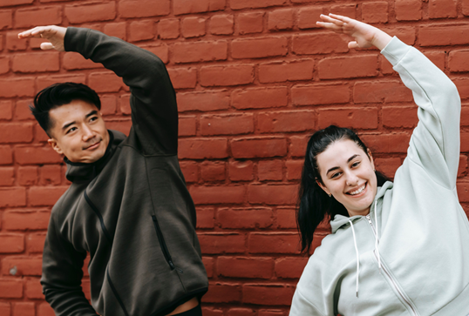  Religious Education  RE  Introduce the concept of life and death rituals  Discuss why rituals are important within Hinduism, Christianity, Buddhism, Judaism and Islam  Explore common themes in life and death rituals (e.g., community, symbolism, transition).  Encourage students to share their thoughts on life and death.  Explore Hindu beliefs about life, death, and reincarnation.  Discuss major Hindu rituals such as cremation and the role of the Ganges River.  Examine Buddhist views on life, death, and the cycle of rebirth.  Discuss Buddhist funeral rituals and practices.  Explore Christian beliefs about life, death, and the afterlife.  Discuss Christian funeral rites and traditions.  Examine Islamic beliefs about life, death, and the afterlife.  Discuss Islamic funeral rites and burial practices.  Explore Jewish views on life, death, and the concept of an afterlife.  Discuss Jewish funeral customs and mourning rituals. | Careers  Students will explore a range of revision and independent study skills to assist in their preparation for the summer exams. They will practice a range of techniques in order that they discover the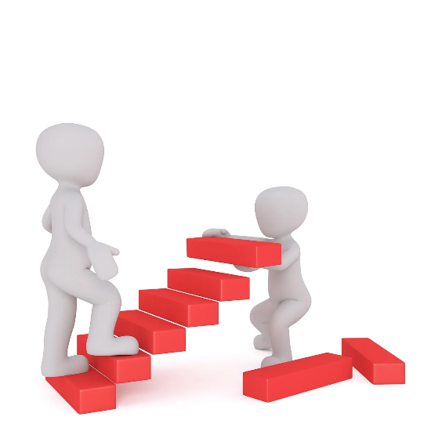 methods that work best for them. They will also do some work around time management and the importance of planning the most effective use of the time in the run up to the summer exams | Young people will spend this half term focused on the Skill section, specifically cooking. They will begin to explore a variety of meal options that can be practiced before being transferred to being cooked on a Trangia. This will involve identifying what they like to eat, finding recipes, making a shopping list, going to our local supermarket and preparing the dish. As always it will continue to be filled with lots of fun and laughter alongside building independence ready for the expedition! They will set themselves personal challenges to push them outside their comfort zone to explore the unknown. Alongside all of this we continue to support young people to develop friendships, improve their self-esteem and build confidence.  

