Year 10 Overview of Learning Pupils from Sapphire, Quartz & Amethyst Bases | This term we are learning about  “What Can We Learn From Space?” | 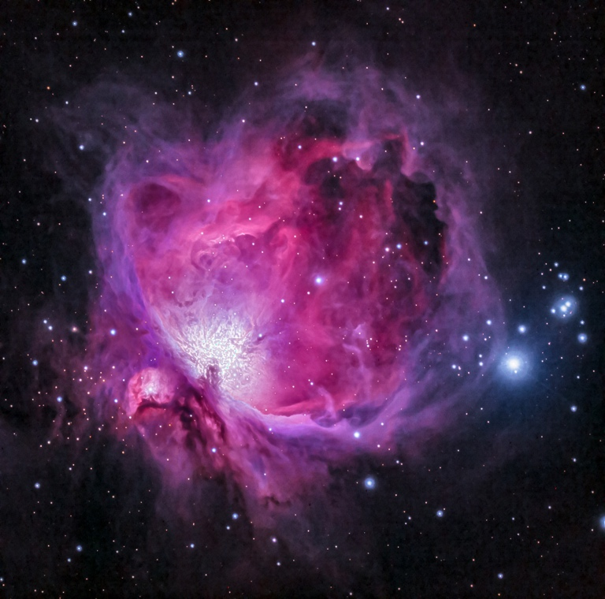  What can we learn from space? | Our Change Maker principle, this  term is ‘Love’ | 

English – GCSE or Entry Level | Maths – GCSE or Entry Level | Science – GCSE or Entry Level | iMedia Cambridge Nationals or Performing Arts BTEC | PSHE/RSE & Personal Development
Year 10 GCSE English Flight Path Three  This term young people taking the English Language GCSE in May will embark on revision for Paper Two of the Eduqas English Language GCSE. Young people will focus on the skills crucial for success in this paper such as picking out key language techniques and analysing their impact on the reader. As well as this, the key focus of the term will be to aid young people in refining their ability to comprehend and analyse unseen texts; fostering critical thinking and honing effective writing strategies. Additionally, we will work with young people to help them to develop plans for the Creative Writing component. Emphasising the importance of imaginative expression and precise language use, whilst creating a series of writing options to choose from to boost their confidence for the upcoming exams  Y10 Entry Level English Flight Path Two  Identifying Writing Formats: Introduce various writing formats such as emails, letters, reports, and instructions. Discuss the purpose, structure, and language features of each format.  Activity: Analyse sample texts of different formats. Discuss key elements and practice identifying writing styles.  This will include:  Punctuation  Capitalisation  Email etiquette  Letter writing | Year 10 GCSE Pathway 3  This term students are building on previous learning of geometry and measure. We will be looking in more detail about 2D and 3D shapes with an emphasis on the technical information and vocabulary.  Students will be working on constructing accurate nets of 3D shapes and working out the surface area. We will conclude this module by learning to calculate the volume of the different 3D shapes along with effective calculator use.  We will conclude this term by working on percentage problems focusing on percentage increase, decrease and reverse percentage problems.  Year 10 Entry Level Pathway 2  During this half term the young people will be looking deeper into the use of Decimals and how this associates with other numbers such as Fractions.  We will continue to develop our skills for using the 4 operations which include using addition, subtraction, multiplication and division to 2 digit numbers  Students will also continue to recap and consolidate their knowledge from previous learning throughout the term. This will include reading, writing and ordering numbers and identifying and working out number sequences and patterns. | Year 10 GCSE Pathway 3  Communicable and non-communicable diseases.  Students will follow on from their study of the structure and function of the heart by looking at health problems associated with the heart, and how they can be treated. · They will look into how smoking, drinking and exercise can affect health and the risk factors associated with non-communicable diseases such as diabetes, lung and liver disease and cardiovascular disease. We will be exploring some causes of cancer and the difference between malignant and benign tumours. We will be delving into how microbes enter the body and the symptoms and mode of transmission of malaria (including the lifecycle of plasmodium) and describe treatment and prevention. We will also be looking at some plant diseases - the symptoms and effects of Tobacco mosaic virus and Rose black spot fungal infection and the physical and chemical ways plants can defend themselves against microorganisms.  Year 10 Entry Level Pathway 2  Elements, mixtures and compounds.  Students will delving atoms and the periodic table of elements; how it arranged including properties of groups 1 and 7 and the location of metals and non-metals on it. We will look at how compounds are formed and learn how to write word equations for the reactions of metals and non-metals, reactions of non-metals to produce oxides. We will explore how structure affects properties of matter (the difference between diamond and graphite as different forms of carbon) and learn how to represent the 3 states of matter and changes of state using particle diagrams. We will complete a practical investigation comparing the melting point of different substances. · | Year 10 iMedia Cambridge Nationals (GCSE equivalent qualification)  Students will continue to progress through their Creative iMedia coursework designing and creating a digital graphic for the ”History of the Isles” game loading screen. They will begin to explore the use of specialist photo editing software to create their graphic    Year 10 Performing Arts (GCSE equivalent qualification)  Students will explore Unit 1 in further detail by performing as a group and developing ensemble skills. They will discuss the importance of ensemble skills and explore potential pieces for their Unit 1 entries.  Students will continue to develop their vocabulary before their controlled assessments begin next term. They will understand key terms such as accuracy, fluency, ensemble etc. | PSHE/RSE Skills  - The impact of financial decisions and the role of advertising on financial choice.  - Next steps: application processes for further education.  Personal Development

History – Year 10 GCSE | BTEC Home Cooking Skills – Year 10 | Physical Education & Religious Education | Careers & Study Skills | Duke of Edinburgh Silver Award
This term students will be examining medical treatment on the Western Front during World War One. They will be looking at the trench network and the chain of evacuation. They will be looking at development in treatments for a wide range of new injuries such as shrapnel and gas attacks. They will also study the advancements that were made in the fields of x-rays, blood grouping and plastic surgeries. | Students will be exploring the economical benefits of batch cooking in comparison to takeaway food. They will be making a wide range of common recipes which associate with takeaway food as well as developing a wide range of skills.  Students will continue to develop their knowledge of the importance of food hygiene and safety, demonstrating this within their coursework. Students will continue to follow a wide range of recipes independently and work towards their Unit 2 – Making And Preparing A Two Course Meal. | Physical Education  In PE young people will be exploring gymnastics. They will be encouraged to develop their technique and improve their performances using a variety of skills. Young people will be encouraged to analyse their own performances, comparing them to previous ones to demonstrate improvements. They will be encouraged to identify areas of sport they enjoy, researching local outside clubs they may wish to attend. Alongside this young people will begin to look at key sports leadership skills, learning about leadership qualities and styles together with planning their own short activity to lead.  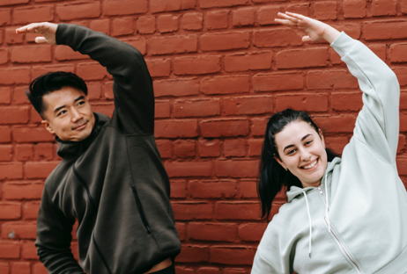  Religious Education  RE  Introduce the concept of life and death rituals  Discuss why rituals are important within Hinduism, Christianity, Buddhism, Judaism and Islam  Explore common themes in life and death rituals (e.g., community, symbolism, transition).  Encourage students to share their thoughts on life and death.  Explore Hindu beliefs about life, death, and reincarnation.  Discuss major Hindu rituals such as cremation and the role of the Ganges River.  Examine Buddhist views on life, death, and the cycle of rebirth.  Discuss Buddhist funeral rituals and practices.  Explore Christian beliefs about life, death, and the afterlife.  Discuss Christian funeral rites and traditions.  Examine Islamic beliefs about life, death, and the afterlife.  Discuss Islamic funeral rites and burial practices.  Explore Jewish views on life, death, and the concept of an afterlife.  Discuss Jewish funeral customs and mourning rituals. | Careers  Students will explore a range of revision and independent study skills to assist in their preparation for the summer exams. They will practice a range of techniques in order that they discover the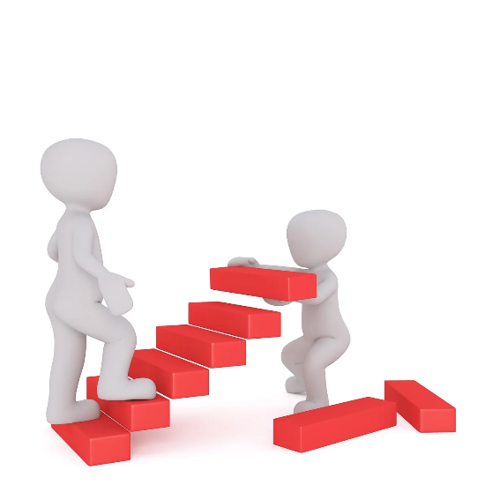 methods that work best for them. They will also do some work around time management and the importance of planning the most effective use of the time in the run up to the summer exams | Young people will spend this half term focused on the Skill section, specifically cooking. They will begin to explore a variety of meal options that can be practiced before being transferred to being cooked on a Trangia. This will involve identifying what they like to eat, finding recipes, making a shopping list, going to our local supermarket and preparing the dish. As always it will continue to be filled with lots of fun and laughter alongside building independence ready for the expedition! They will set themselves personal challenges to push them outside their comfort zone to explore the unknown. Alongside all of this we continue to support young people to develop friendships, improve their self-esteem and build confidence.  

