Year 9 Overview of Learning Pupils from Turquoise, Sapphire & Quartz Bases | This term we are learning about  “What Can We Learn From Space?” |   What can we learn from space? | Our Change Maker principle, this term is ‘Love’ | 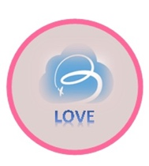

English | Maths | Science | Computing & Careers | PSHE/RSE
Y9 Group A  As part of their work towards their Functional Skills L1 and L2 qualifications, young people will work towards completing the Speaking and Listening component of their qualification this term. An integral part of the Eduqas Functional Skills Level One and Two English qualification, this module emphasises the development of crucial communication skills. Young people will participate in the creation of an individual personal presentation, providing them with a place to express their interests, refine their public speaking abilities, and enhance their overall communication abilities. Young people will also engage in class discussions as a regular aspect of the curriculum, fostering an environment that encourages active listening, critical thinking, and effective verbal expression, preparing them for the world outside Bader.  Y9 Group B  This term, young people will continue their work towards their Entry Level Three qualification in English, focusing on the essential Speaking and Listening component. Throughout this module, young people will actively hone their communication, listening and interaction skills, preparing them for both the qualification and their lives after Bader. A key focus will be the creation of a personal presentation, where young people will have the opportunity to express themselves and showcase their speaking abilities. Additionally, class discussions will be a regular feature, fostering an environment that encourages thoughtful dialogue and active listening. These exercises aim to not only enhance your young people’s ability in spoken language but also develop their confidence in articulating ideas effectively, for the wider world. | Year 9 Group A  Students will be introduced to more topics from Algebra, these are brackets, equations and inequalities. Students will be building on prior learning from previous years enabling them to be able to expand brackets along with solving equations and inequalities.  Students will be introduced to new key vocabulary and modelling techniques allowing to a deeper contextual understanding of Algebra.  Year 9 Group B  Students are excited to start their Entry Level Course. This term we will be looking at money, where students will learn about the British currency denominations and using this to problem solve.  Students will also look at reading analogue clocks and working in both 12 and 24 hour time formats.  We will conclude the term by looking at students being able to Know the number of days in a week, months and seasons in a year; be able to name and sequence | Students will revisit forces and drawing force diagrams, looking more deeply into gravity and using simple equations to carry out calculations to calculate weight on different planets due to gravity. They will be delving into our solar system - the Sun as a star and the centre of our solar system, other bodies that exist in our solar system and our universe using simple statistical techniques to compare planets. They will also be looking into a day as the time it takes for a planet to rotate once on its axis and explain day length at different times of year, in different hemispheres and on different planets. · We will be examining the seasons in relation to the Earth’s tilt and consequent changes in temperature and weather and look at how the moon’s movement relative to the sun can make the moon appear to change shape. | Computing  Students will make use of the new BBC Microbit computers to explore different programming environments and languages. They will learn how to use different inputs and triggers along with developing their understanding of programming concepts including handling variables and loops.  This term also coincides with the annual Safer Internet Day. Students will use this opportunity to discuss and explore a range of online safety issues including cyberbullying, identity theft and legal issues around copyright and computer misuse    Careers & Enterprise:  Students will explore the basics of first aid, knowing when to call for help as well as ensuring that they have followed steps to promote the safety of another person.  Students will continue to explore their future career options and explore the qualifications needed for their chosen career option.  . | - Respectful relationships- families and parenting, healthy relationships, conflict resolution.  - Learn about different relationships and vulnerabilities e.g. fostering, adoption, homelessness.

Geography & History | Art and DT | PE & Music | MFL & RE | Duke of Edinburgh
History  This half term students will be focused on the Trans-Atlantic slave trade. We will be discussing, 'what is slavery?' We will be exploring the slave triangle and the dangerous of the middle passage. We will also be looking at slave auctions and what life was like on slave plantations and the different job roles. We will then look at the abolitionist movement and the calls to end slavery.  Geography  This term students will be focused on the process of migration. Students will explore what is meant by migration and the different forms of migration - economic, internal etc. We will also be looking at the different push/pull factors that influence people to migrate. We will consider the positive and negative views that people hold towards migrants, as well as looking at the impact of urbanisation and counter- urbanisation | Art  Students will be learning how to use digital art software on the iPad using the pen stylus. We will explore using layers to create depth and produce a piece of space artwork. They will then start to learn how to use animation software to create a short animation on the iPad.  Woodwork  Students will learn the basics of working with wood, including developing accuracy skills in the measuring, marking and sawing of wood. They will explore the use of basic wood joining techniques. They will use these skills to create a simple wooden puzzle as the term progresses  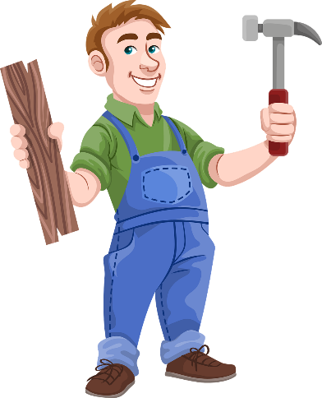  OR  Food Technology  Students will demonstrate their culinary skills by making a wide range of recipes exploring a wide range of skills. They will work independently to follow recipes demonstrating their ability to adapt as well as measure out ingredients carefully and accurately.  Over the term, students will make both simple and complex dishes developing skills such as boiling, frying, cutting accurately with a knife, measuring etc. | PE  In PE young people will be exploring gymnastics. They will be encouraged to develop their technique and improve their performances using a variety of skills. Young people will be encouraged to analyse their own performances, comparing them to previous ones to demonstrate improvements. They will be encouraged to identify areas of sport they enjoy, researching local outside clubs they may wish to attend.  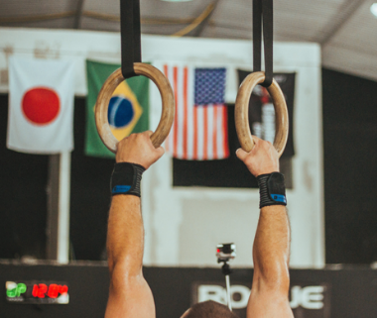  Music  Students will be creating a theme and variation composition on GarageBand using iPads. They will recap and explore the basic functions of this app, specifically further demonstrating their knowledge by adding in a new section and creating a rhythmic accompaniment using different instruments.  Students will explore the term 'Theme and Variation' itself, composing their own variation based upon a given theme. They will explore how this can be created both rhythmically and melodically.  Students will continue to explore and further broaden their knowledge of the musical dimensions by commenting on a wide range of elements when listening to various pieces of music. | Spanish  Students will continue to learn a range of basic Spanish vocabulary and practice taking part in simple conversations. This term will focus on the vocabulary of the different seasons  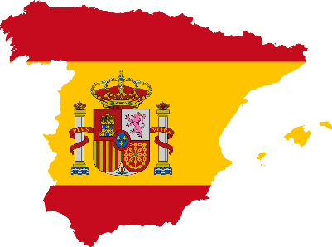  RE  RE  Introduce the concept of life and death rituals  Discuss why rituals are important within Hinduism, Christianity, Buddhism, Judaism and Islam  Explore common themes in life and death rituals (e.g., community, symbolism, transition).  Encourage students to share their thoughts on life and death.  Explore Hindu beliefs about life, death, and reincarnation.  Discuss major Hindu rituals such as cremation and the role of the Ganges River.  Examine Buddhist views on life, death, and the cycle of rebirth.  Discuss Buddhist funeral rituals and practices.  Explore Christian beliefs about life, death, and the afterlife.  Discuss Christian funeral rites and traditions.  Examine Islamic beliefs about life, death, and the afterlife.  Discuss Islamic funeral rites and burial practices.  Explore Jewish views on life, death, and the concept of an afterlife.  Discuss Jewish funeral customs and mourning rituals.  Personal Development | Young people will spend this half term focusing on Physical and Skill. They will begin to explore these two sections completing a variety of activities. As always it will continue to be filled with lots of fun and laughter alongside building independence, developing fitness and essential skills for life and the expedition. They will set themselves personal challenges to push them outside their comfort zone to explore the unknown. Alongside all of this we continue to support young people to develop friendships, improve their self-esteem and build confidence.  

