Year 8 Overview of Learning Pupils from Emerald and Coral Bases | This term we are learning about  “What Can We Learn from Space?” | 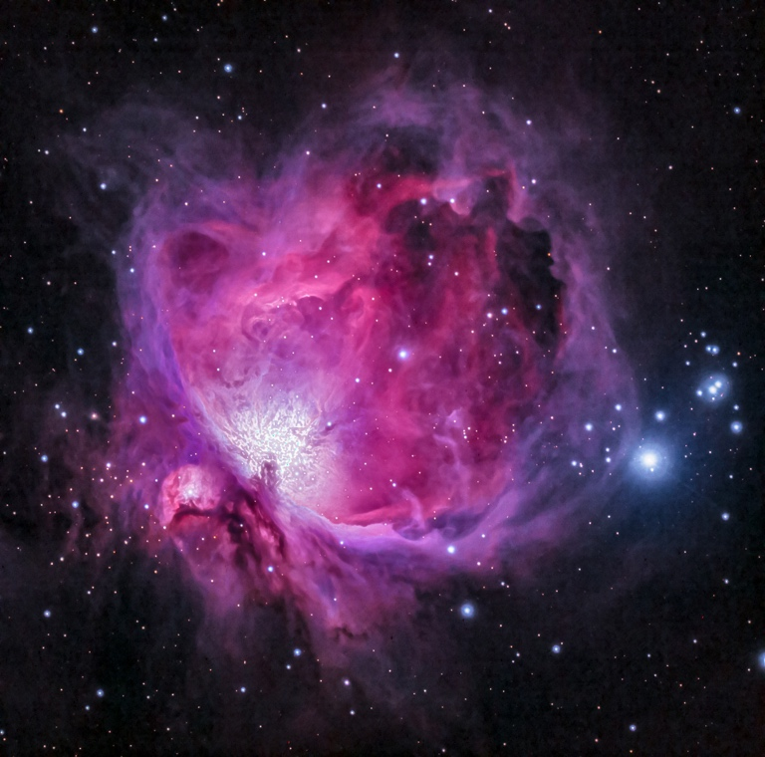  What can we learn from space? | Our Change Maker principle, this term is ‘Love’ | 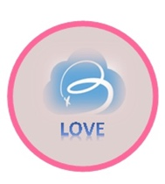

English | Maths | Science | Computing & Careers | PSHE/RSE
This term, young people in Year 8 will be delving into the world of "Poetry, Myths, and Monsters" using the poetry anthology 'Falling Out of the Sky.' Throughout this exploration, young people will develop a keen understanding of various poetic techniques and learn to recognise them within poems. Some young people will then extend this knowledge and discuss how these techniques impact readers. The topic will also encourage thoughtful discussions on characters and settings in mythical contexts, extending young people’s imaginations and fostering critical thinking. As a culmination, young people will have the opportunity to channel their insights into creating their own poems inspired by ideas of Myths and Legends.  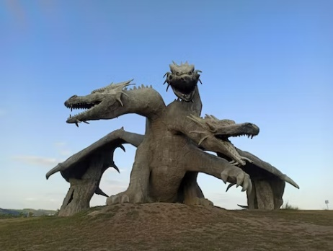 | Year 8 Group A  Students will be introduced to more topics from Algebra, these are brackets, equations and inequalities. Students will be building on prior learning from previous years enabling them to be able to expand brackets along with solving equations and inequalities.  Students will be introduced to new key vocabulary and modelling techniques allowing to a deeper contextual understanding of Algebra.  Year 8 Group B  Students are learning about Ratio in a range of contexts from comparing items to using ratio to increase and decrease the size of shapes. Students will look further into using ratio through recipes and scale drawings.  Students will also explore the differences between ratio and fractions as well as how they are closely related giving them a deeper understanding of when to apply using ratios and when to use fractions. | Students will revisit forces and drawing force diagrams, looking more deeply into gravity and using simple equations to carry out calculations to calculate weight on different planets due to gravity. They will be delving into our solar system - the Sun as a star and the centre of our solar system, other bodies that exist in our solar system and our universe using simple statistical techniques to compare planets. They will also be looking into a day as the time it takes for a planet to rotate once on its axis and explain day length at different times of year, in different hemispheres and on different planets. · We will be examining the seasons in relation to the Earth’s tilt and consequent changes in temperature and weather and look at how the moon’s movement relative to the sun can make the moon appear to change shape. | Computing  Students will make use of the new BBC Microbit computers to explore different programming environments and languages. They will learn how to use different inputs and triggers along with developing their understanding of programming concepts including handling variables and loops.  This term also coincides with the annual Safer Internet Day. Students will use this opportunity to discuss and explore a range of online safety issues including cyberbullying, identity theft and legal issues around copyright and computer misuse    Careers and Enterprise  This half-term young people will learn the importance of a variety of skills needed for the world of work. They will complete practical activities along with research tasks to develop these skills personally. Some of the skills include, communication, teamwork, leadership, resilience, organisation, creativity and more. | - Learning about strengths, goal settings and options.  - Learning about diversity, prejudice and bullying.

Geography & History | Art and DT | PE & Music | MFL & RE
History  Y8-This half term students will be focused on the Trans-Atlantic slave trade. We will be discussing, 'what is slavery?' We will be exploring the slave triangle and the dangerous of the middle passage. We will also be looking at slave auctions and what life was like on slave plantations and the different job roles. We will then look at the abolitionist movement and the calls to end slavery.  Geography  Y8 - This term students will be focused on the process of migration. Students will explore what is meant by migration and the different forms of migration - economic, internal etc. We will also be looking at the different push/pull factors that influence people to migrate. We will consider the positive and negative views that people hold towards migrants, as well as looking at the impact of urbanisation and counter- urbanisation | Art  Students will be learning how to use digital art software on the iPad using the pen stylus. We will explore using layers to create depth and produce a piece of space artwork.  Woodwork  Students will learn the basics of working with wood, including developing accuracy skills in the measuring, marking and sawing of wood. They will explore the use of basic wood joining techniques. They will use these skills to create a simple wooden puzzle as the term progresses  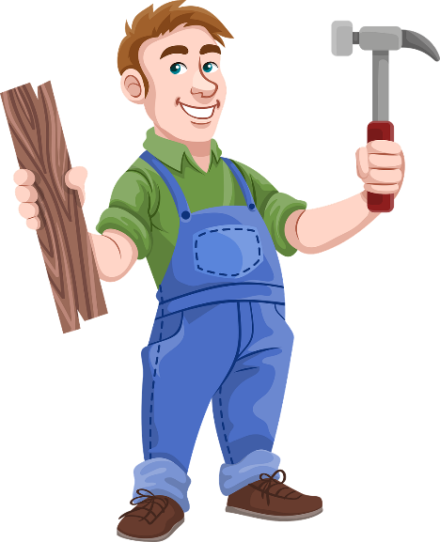  OR  Food Technology  Students will demonstrate their culinary skills by making a wide range of recipes exploring a wide range of skills. They will work independently to follow recipes demonstrating their ability to adapt as well as measure out ingredients carefully and accurately.  Over the term, students will make both simple and complex dishes developing skills such as boiling, frying, cutting accurately with a knife, measuring etc. | PE  In PE young people will be exploring gymnastics. They will be encouraged to develop their technique and improve their performances using a variety of skills. Young people will be encouraged to analyse their own performances, comparing them to previous ones to demonstrate improvements. They will be encouraged to identify areas of sport they enjoy, researching local outside clubs they may wish to attend.    Music  Students will be creating a theme and variation composition on GarageBand using iPads. They will recap and explore the basic functions of this app, specifically further demonstrating their knowledge by adding in a new section and creating a rhythmic accompaniment using different instruments.  Students will explore the term 'Theme and Variation' itself, composing their own variation based upon a given theme. They will explore how this can be created both rhythmically and melodically.  Students will continue to explore and further broaden their knowledge of the musical dimensions by commenting on a wide range of elements when listening to various pieces of music. | Spanish  Students will explore the different seasons and broaden their knowledge of key phrases related to each season.  Students will also develop their listening skills, being able to identify spoken phrases and practise this within their lessons.  RE  Introduce the concept of life and death rituals  Discuss why rituals are important within Hinduism, Christianity, Buddhism, Judaism and Islam  Explore common themes in life and death rituals (e.g., community, symbolism, transition).  Encourage students to share their thoughts on life and death.  Explore Hindu beliefs about life, death, and reincarnation.  Discuss major Hindu rituals such as cremation and the role of the Ganges River.  Examine Buddhist views on life, death, and the cycle of rebirth.  Discuss Buddhist funeral rituals and practices.  Explore Christian beliefs about life, death, and the afterlife.  Discuss Christian funeral rites and traditions.  Examine Islamic beliefs about life, death, and the afterlife.  Discuss Islamic funeral rites and burial practices.  Explore Jewish views on life, death, and the concept of an afterlife.  Discuss Jewish funeral customs and mourning rituals.  Personal Development  We will be looking at the importance of living a healthy active lifestyle. They will begin to explore what this lifestyle involves including healthy diets. Young people will develop skills to create a healthy dish. They will access a local supermarket to purchase the ingredients and will be encouraged to prepare the dish as independent as possible. For this to happen young people will develop research skills to find a recipe and create a shopping list, using mathematical skills to understand prices and to work out how much the dish is going to cost.  

