Ruby Base | This term we are learning about  “What can we learn from space?” | 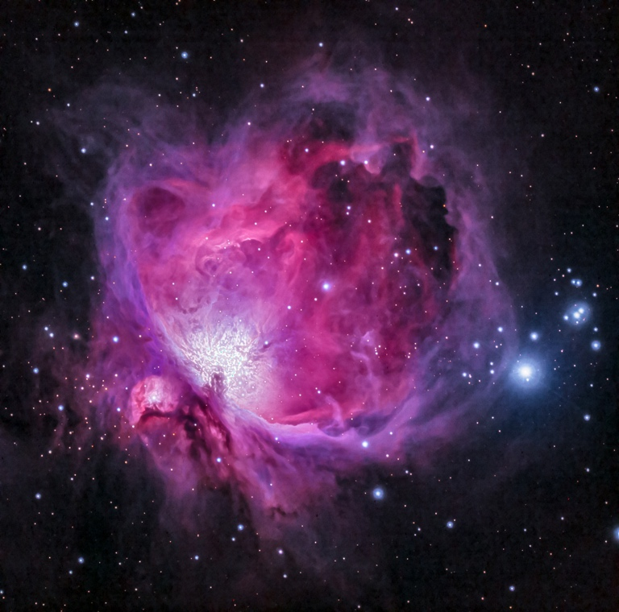  What can we learn from space? | Our Change Maker principle, this term is 'Love’ | 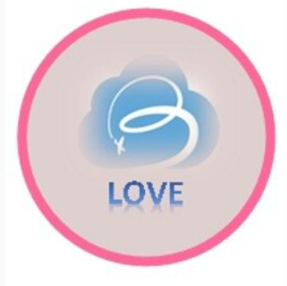

English |  | Maths | Science |  | Computing | PSHE/RSE
Text- Fantastic Mr Fox  Answering retrieval questions and predicting what might happen next.  To be able to draft write by composing a sentence orally before writing it.  Start sentences with capital letters, use finger spaces to separate words and end sentences with full stops.  Extending sentences by using more than one clause and using a range of conjunctions such as when, if, because and although  Including the accurate use of pronouns whilst writing sentences  Ensuring writing is legible and fluent  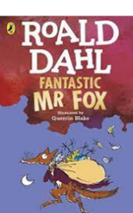  Develop our understanding of vocabulary and unfamiliar words.  Writing a newspaper  Sequencing and recounting events in a story |  | Multiplication- Writing and calculating mathematical statements for multiplication and division  Learning to multiply 2-digit numbers by 1 digit  Recognising multiplication facts and tables of 2s, 3s, 4s, 5s and 10s  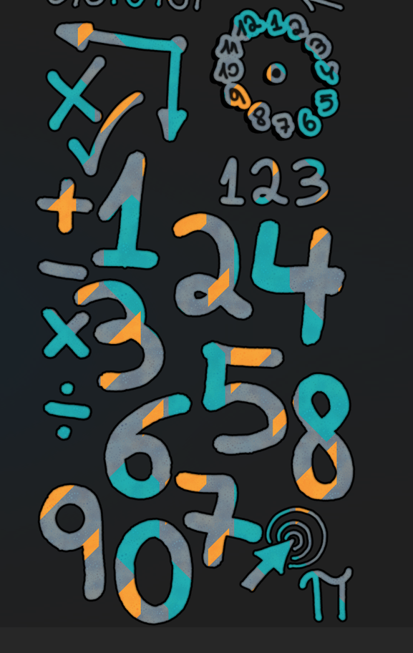 | Space and the solar system  Describing the Sun, Moon, and Earth as spherical bodies  Investigating and describing the movement and phases of the moon relative to the Earth  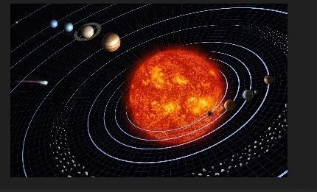  Understanding, remembering and replicating the solar system with accuracy |  | Using technology safely and respectfully  Using a range of software to create a appealing advert  E-Safety and Digital Citizenship-  Exploring how the internet impacts daily lives  Learning how and why we communicate through electronic devices and the safety aspects of talking online  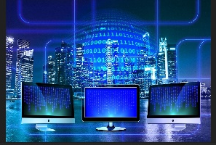  Learning the importance of reporting concerns online | Belonging to a community-  Learning about living in a community and the rules and expectations  Beginning to learn about prejudice and discrimination in the world and the impact this can have  Exploring how we can look after the environment  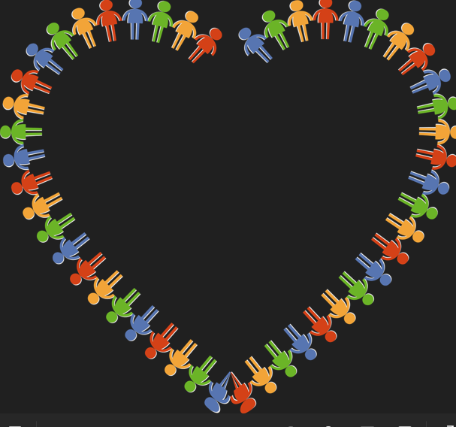
Geography & History | Art and DT |  |  | PE & Music |  |  | MFL & RE
In Geography we are:  Using grid references (4 figure and 6 figure) on a map to build knowledge of the UK.  Finding cities in the UK on a map or an atlas and identifying what country they are in.  To be able to explain the difference between British Isles, Great Britain and the United Kingdom  Using the correct geographical words to describe places in the UK such as hills, mountains, coasts and rivers.  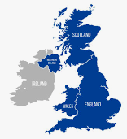  In History we are learning about the Stuarts:  To be able to sequence the main events of the Stuart period  Looking at the main people of the Stuart period including Charles 1st, Charles 2nd and Oliver Cromwell.  Exploring the events of the civil war | In Art we are learning to:  Use IT to create which includes authentic pieces and work similar and in the style of other artists  Use a range of techniques and media including painting  To use a range of techniques to record observations, in sketchbooks, journals and other media for exploring ideas  Use correct terminology when discussing art to demonstrate knowledge  In Design and Technology, we are:  Designing and making a rang3e of space equipment such as helmets, space suits and the Solar system  Investigating simple mechanisms.  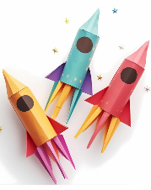  Using a research proposal and design to create a finished product  Exploring materials and tools  Learning to follow a step by step plan and choosing the right equipment to make an appealing product |  |  | In PE we will be exploring Gymnastics. Young people will learn how to use equipment and apparatus safely. They will explore moving in a variety of ways with control and care. Young people will be encouraged to copy, repeat, remember and create sequences independently and with a partner. They will be given time to showcase their ideas to the rest of the class.  Music-  Students will be exploring the different sounds of boomwhackers as well as performing in an ensemble. They will be exploring popular pieces of music within their group, exploring the tone each boomwhacker makes as well as key ensemble skills such as performing in time and with accuracy.  Students will continue to develop their knowledge of the musical dimensions, specifically commenting on these during listening activities |  |  | In Spanish we are learning about Instruments:  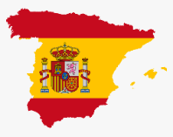  Being able to recall, remember and spell up to 10 instruments  To able to build a simple sentence with the verb “I am” and with correct pronunciation  RE  Chinese New year- Investigating the traditions and foods that are traditional.  Investigating life and death

