Pearl Base | This term we are learning about  “What can we learn from space?” | 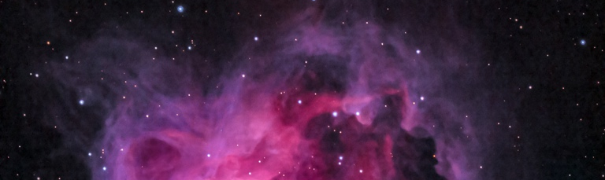  What can we learn from space? | Our Change Maker principle, this term is 'Love’ | 

English | Maths | Science |  | Computing |  | PSHE/RSE
This half term, Pearl Class will be reading: Wolf Wilder by Katherine Rundell.    Pupils will develop an appreciation and love of reading, and read increasingly challenging material independently. They will develop creative expression.  They will write accurately, fluently, effectively and at length for pleasure and information. They will achieve this by exploring the setting and characters, themes and symbolism.  They will be introduced to point, evidence, explain (PEE) paragraphs and learn to successfully analyse information learnt through the medium of newspaper writing. | Pupils will learn about Multiples, factors, prime numbers and square numbers,  multiplying by 10, 100 and 1000.    Equivalent fractions, comparing and ordering fractions, mixed fractions and improper fractions.    Understanding and using algebraic notations.   | We will revisit forces, looking into gravity and using simple equations to calculate weight on different planets. We will be delving into our solar system - the Sun as a star and the centre of our solar system, other bodies that exist in our solar system and our universe using simple statistical techniques to compare planets. We will be looking into the time it takes for a planet to rotate once on its axis and explain day length at different times of year, in different hemispheres and on different planets. We will be examining the seasons in relation to the Earth’s tilt and consequent changes in temperature and weather and look at how the moon’s movement relative to the sun can make the moon appear to change shape. |  | 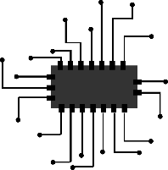  Students will make use of the new BBC Microbit computers to explore different programming environments and languages.  They will learn how to use different inputs and triggers along with developing their understanding of programming concepts including handling variables and loops.  This term also coincides with the annual Safer Internet Day.  Students will use this opportunity to discuss and explore a range of online safety issues including cyberbullying, identity theft and legal issues around copyright and computer misuse. |  | Pupils will study living in the wider world.  They will learn about diversity, prejudice and bullying.  They will also think about discrimination in a range of different forms.  
History & Geography | Art and DT |  | PE & Music |  | MFL & RE
History  This term students will be examining the different methods of attacking and defending a medieval castle. We will then be moving onto looking at life in medieval England. This will include exploring the common types of crime and the different, and often barbaric punishments. As well as looking at the role of the church and religion in people’s lives. The unit will conclude with a case study on the Black Death.  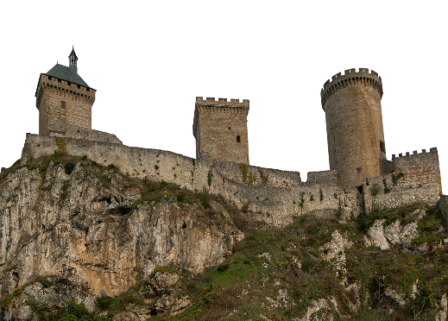  Geography  Young people will be able to understand the key processes in weather and climate.  We will be focusing on:  The process of cloud formation and the different types of cloud,  the different types of precipitation,  the causes and effects of high and low pressure fronts, the causes and effects of heatwaves, the different air masses that influence the UK’s weather systems and depressions and how these can be used to predict the movement of weather systems.  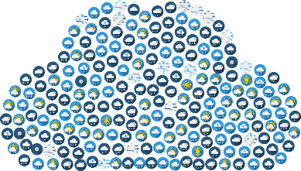 | Art  This term young people will be focusing on creating mixed media artwork including the use of digital art. They will increase their proficiency in the handling of different materials to create work based on Victorian Silhouette portraits, Personal Logos and Tags and then 3D digital art inspired by the style of ‘Minecraft’.  Students will use a range of techniques and media, including painting to record their observations in sketchbooks, journals and other media as a basis for exploring their ideas.    DT  Students will be using research and exploration techniques to design and build a satellite choosing from a range of different complex materials. They will focus on how to solve and reformulate their design problems by communicating their ideas using annotated sketches, detailed plans, 3D mathematical modelling, oral and digital presentations and computer-based tools. Students will then evaluate and showcase their products.  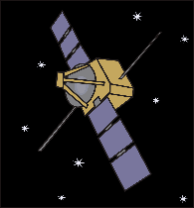  Food Technology  Pupils will compare foods that are grown, processed, reared and caught. They will understand that seasons may affect the food available and be able to identify substances such as fruit and vegetables, carbohydrates, protein, dairy and fatty foods. They will learn how to prepare and cook a variety of predominantly savoury dishes safely and hygienically including the use of a heat source, and practice how to use a range of techniques such as peeling, chopping, slicing, grating, mixing, spreading, kneading and baking.   |  | PE  We are covering Gymnastics. Young people will learn how to use equipment and apparatus safely. They will explore moving in a variety of ways with control and care. Young people will be encouraged to copy, repeat, remember and create sequences independently, with a partner and as part of a small group. They will be given time to develop their leadership skills and showcase their ideas to the rest of the class. Young people will be encouraged to compare their sequences with previous ones to identify areas of improvement.    Music  Students will be creating a theme and variation composition on GarageBand using iPads. They will recap and explore the basic functions of this app, specifically further demonstrating their knowledge by adding in a new section and creating a rhythmic accompaniment using different instruments.  Students will explore the term 'Theme and Variation' itself, composing their own variation based upon a given theme. They will explore how this can be created both rhythmically and melodically.  Students will continue to explore and further broaden their knowledge of the musical dimensions by commenting on a wide range of elements when listening to various pieces of music.  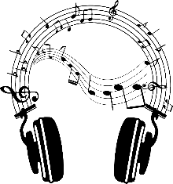 |  | MFL  Pupils will practise basic phonic knowledge for pronunciation and spelling of Spanish words.  They will work on improving memory skills through a variety of interactive activities.    RE  Pupils will learn about ‘Life and Death’ and how these are celebrated across the faiths.  

