Opal Base | This term we are learning about  “What can we learn from space?” | 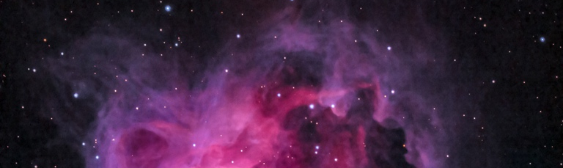  What can we learn from space? | Our Change Maker principle, this term is 'Love’ | 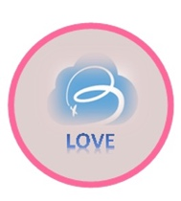

English | Maths | Science |  | Computing |  | PSHE/RSE
SATs preparation  Reading  Fiction, Non-fiction and Poetry  Focus on key reading skills:  Retrieval, inference, prediction, vocabulary, sequencing  Spelling, Punctuation and Grammar  SATs prep  Writing  SATs prep  Fiction  Short short stories (The Sound of Thunder, The Veldt and The Weapon) and a Dystopian short story 'Harrison Bergeron'.  Non-fiction  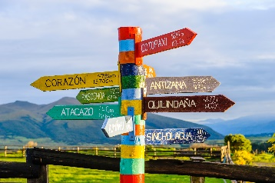  work on 'Travel Writing' creating your own travel guides and persuasive pieces. | SATs prep  Arithmatic  Place Value  Addition, subtraction, multiplication, division  Fractions  Addition, subtraction, multiplication, division, simplifying  Decimal, percentages  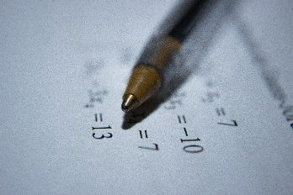  Reasoning  Shape  Time  Area, perimeter, volume | Space  Learn about the Sun, Earth and Moon as approximately spherical bodies, the movement of the Earth, and other planets, relative to the Sun in the solar system – heliocentric v geocentric  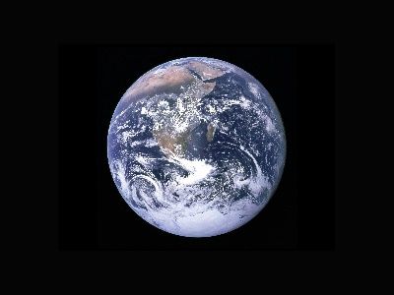  Learn about the idea of the Earth’s rotation to explain day and night and the apparent movement of the sun across the sky. |  |   E-safety & Digital Citizenship  This year’s Safer Internet Day theme is “Together for a Safer Internet”  Digital Citizenship activities should revolve around raising awareness of how the internet has revolutionised our lives, how we communicate with each other through the internet and what the correct etiquette for this |  | Living in the wider world  Valuing diversity, challenging discrimination and stereotypes  Evaluation media sources, sharing things online  Influences and attitudes to money and financial risks  
Geography & History | Art and DT |  | PE & MFL |  | Music & RE
History  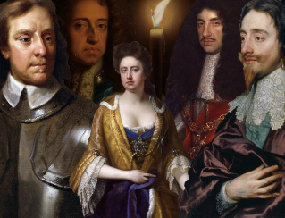  The Stuarts  Students will learn about:  The development of Church, state and society in Britain 1509-1745.  Charles I and his view on Monarchical rule.  The outbreak of Civil War  The reinstating of the Monarch under Charles II.  Geography  Geographical Skills and Fieldwork  Students will be able to:  Use the 8 points of a compass ·  Four and six-figure grid references · Symbols and key (including the use of Ordnances Survey maps) to build their knowledge of the UK and the wider world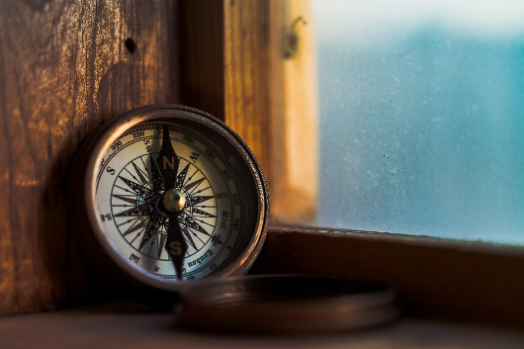 | Art  IT in Art  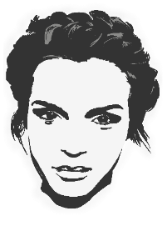  Students will be using IT to create art which includes their own work and that of others. They will use digital images and combine with other media in my art  DT  To make a model of the moon cycle  Food Technology  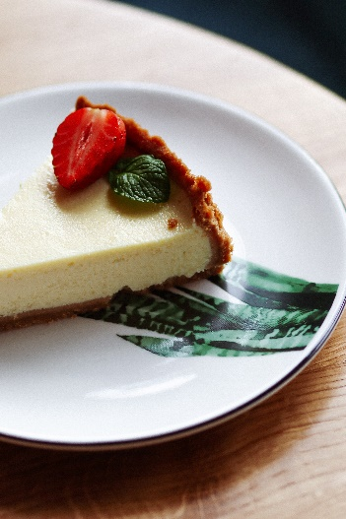  Chicken pie, cheesecake, pizza pin wheels, chocolate buns |  | PE  Gymnastics  Students will learn how to use equipment and apparatus safely. They will explore moving in a variety of ways with control and care. Young people will be encouraged to copy, repeat, remember and create sequences independently, with a partner and as part of a small group.  Young people will be encouraged to compare their sequences with previous ones to identify areas of improvement.  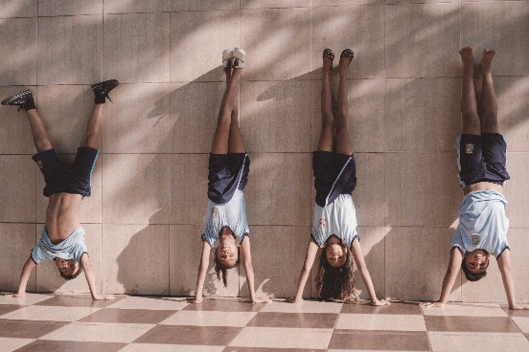  MFL  Pupils will learn 10 familiar activities that they know how or do not know how in Spanish. · Introducing the negative form, to build more interesting and complex sentences including the option of using conjunctions.  Recognise, remember and spell 10 action verbs in Spanish. • |  | Music  Students will be creating a theme and variation composition on GarageBand using iPads. They will recap and explore the basic functions of this app, specifically further demonstrating their knowledge by adding in a new section and creating a rhythmic accompaniment using different instruments.  Students will explore the term 'Theme and Variation' itself, composing their own variation based upon a given theme. They will explore how this can be created both rhythmically and melodically.  RE  Religious ceremonies around Life and Death

