Jet Base | This term we are learning about  “What can we learn from space?” | 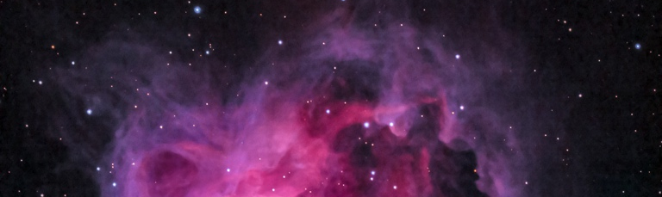  What can we learn from space? | Our Change Maker principle, this term is 'Love’ | 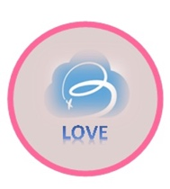
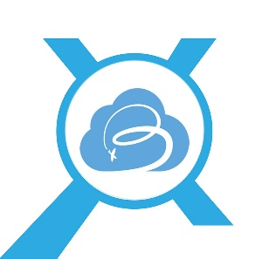
English | Maths | Science |  | Computing |  | PSHE/RSE
Our books/hooks this half term will be linked to space.  Students will be:  Writing for different purposes.  Writing about real events.  Writing poetry.  Students will be able to:  Use subordination (when, if, that, because) and co-ordination (or, and, but).  Use expanded noun phrases to describe and specify (e.g. the blue butterfly).  Use sentences with different forms: statement, question, exclamation, command.  Encapsulate what they want to say, sentence by sentence.  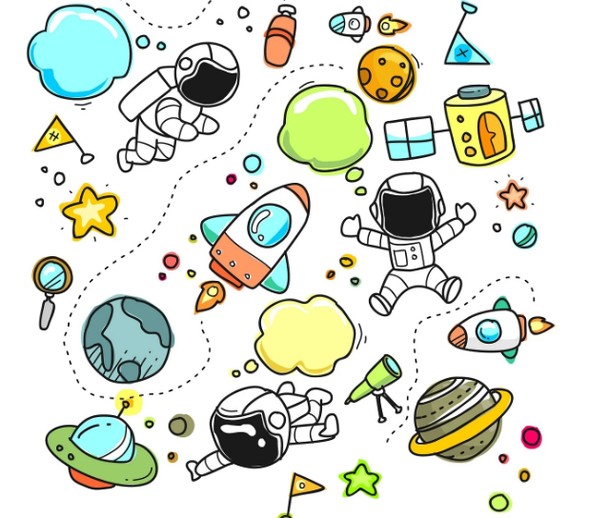 | Students will be:  Multiplying and dividing using sharing and grouping strategies.  Learning multiples of 2, 5 and 10. Then moving on to learning multiples of 3, 4 and 8.  Learning about 2D shapes and their properties. Learning about 3D shapes and their properties.  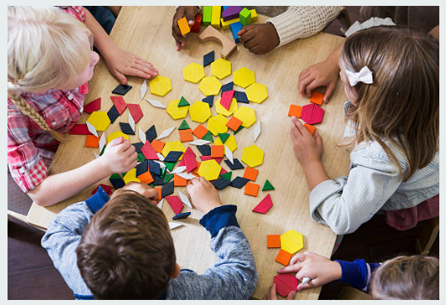 | This Half Term we will be learning about light and dark.  Students will:  Be able to recognise that they need light in order to see things and that dark is the absence of light.  Notice that light is reflected from surfaces.  Recognise that light from the sun can be dangerous and that there are ways to protect their eyes.  Recognise that shadows are formed when the light from a light source is blocked by a solid object.  Find patterns in the way that the size of shadows change. |  | Students will:  Be able to use technology safely and respectfully, keeping personal information private; and identify where to go for help and support when they have concerns about content or contact on the internet or other online technologies.  Recognise common uses of information technology beyond school.  Use technology purposefully to create, organise store, manipulate and retrieve digital data. |  | Students will:  Be able to describe ways that they can be a good neighbour.  Be able to describe different ways to pay for things.  Be able to describe how you get money and why you need it.  Learn how to be safe on the Internet, what is appropriate and who they can trust to talk about any issues.  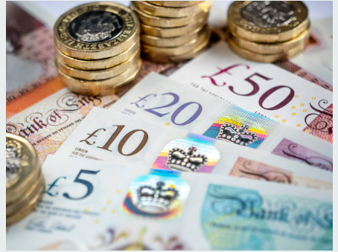
Geography & History | Art and DT |  | PE & Music |  | MFL
History  This Half Term we will be learning about the Victorians.  Students will:  Learn about the life of Queen Victoria and when she reigned.  Learn about what it was like to be a child in Victorian times, including going to work and school life.  Learn about what houses were like in the Victorian times.  Learn about seaside holidays in Victorian times and how they compare to holidays today.  Geography  Students will:  Recap hot and cold parts of the world in relation to the equator and the North/South Poles and find out what animals live there.  Be able to sort countries by their climates.  Be able to label and explain how to use the four compass points.  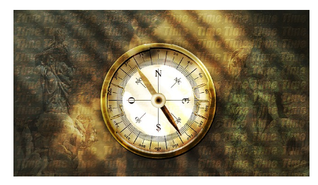 | Art  Students will:  Be able to use printing techniques.  Learn about and create artwork in the style of Kandinsky.  Learn about and create artwork in the style Henri Matisse.  Be able to use a range of sketching skills.  DT  Students will be:  Designing and making a class mobile solar system.  Investigating existing products, including the designs and different materials used.  Selecting and using tools safely and appropriately.  Using our own designs to make a finished product.  Evaluating and presenting our finished mobile to display in the classroom.  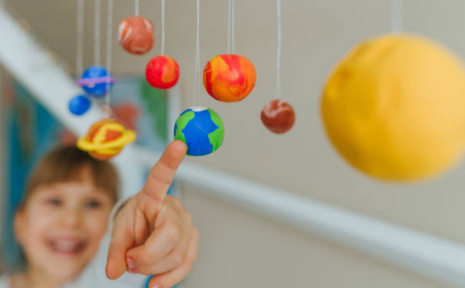  Food Technology  Students will:  Be able to cut food safely to make a healthy dish.  Understand where food comes from. |  | PE  In PE we will be exploring Gymnastics. Young people will learn how to use equipment and apparatus safely. They will explore moving in a variety of ways with control and care. Young people will be encouraged to copy, repeat, remember and create sequences independently and with a partner. They will be given time to showcase their ideas to the rest of the class.  Music:  Students will be composing their own drum beat composition using GarageBand on iPads. They will be exploring the basic functions of this app as well as exploring a variety of sounds which they like or dislike.  Students will continue to develop their rhythmic ability to demonstrate their understanding of beat and pulse (from Autumn 2).  Students will explore a range of musical dimensions in order to create a successful piece of music. |  | MFL  Students will learn how to:  Say 10 common colours in Spanish.  Count from 1-10 in Spanish.  RE  This Half Term in RE we will be learning about how different faiths celebrate life and death.

