Jasper Base | This term we are learning about  “What can we learn from space?” | 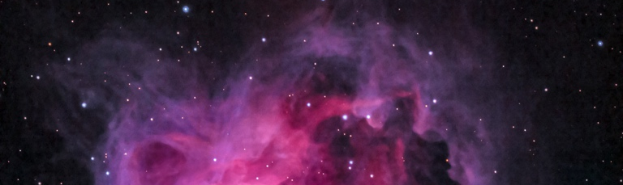  What can we learn from space? | Our Change Maker principle, this term is 'Love’ | 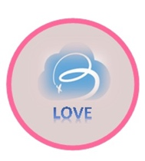

English | Maths | Science |  | Computing |  | PSHE/RSE
This half term students will be focussing on looking at Travel Writing as a style of Non-Fiction writing. We will take an in-depth look at vocabulary, fact and opinion, rhetorical questioning, how to use our knowledge of grammar to write emotive sentences and other language devices. This process will include taking notes and developing initial ideas, drawing on reading and research. The use of organisational and presentational devices to structure text and to guide the reader [for example, headings, bullet points, underlining]. Evaluate and edit by: assessing the effectiveness of their own and others’ writing. To propose changes to vocabulary, grammar and punctuation to enhance effects and clarify meaning.  This will culminate in young people creating a persuasive piece of work writing in the style of a Travel Writer.  Pupils will continue reading for pleasure and our class novel is ‘Rooftoppers’ by Catherine Rundell. We will explore settings, characters and the central themes of the novel.  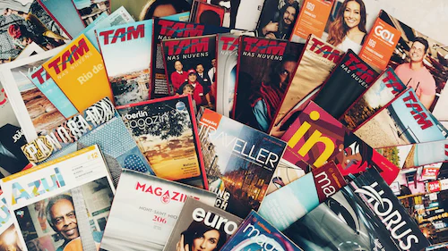 | 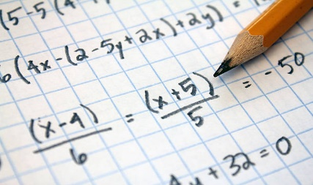Students will work on furthering their formal calculation skills using the four operations of addition, subtraction, multiplication and division. This knowledge will be applied to solving real world word problems.  Then students will move on to looking at Ratios. This will include work on ratio symbols and vocabulary. The relationship between ratios and fractions and using scale factors and drawings.  Young people will be rounding, adding, subtracting, multiplying and dividing decimals this half term.  Some students will extend their learning by using algebraic formulae to form equations. Then looking at solving 2-step problems and finding pairs of values. Then using their knowledge of decimals to learn about decimal, percentage and fraction equivalence. | Students will revisit forces and drawing force diagrams, looking more deeply into gravity and using simple equations to carry out calculations to calculate weight on different planets due to gravity. They will be delving into our solar system - the Sun as a star and the centre of our solar system, other bodies that exist in our solar system and our universe using simple statistical techniques to compare planets. They will also be looking into a day as the time it takes for a planet to rotate once on its axis and explain day length at different times of year, in different hemispheres and on different planets. · We will be examining the seasons in relation to the Earth’s tilt and consequent changes in temperature and weather and look at how the moon’s movement relative to the sun can make the moon appear to change shape. |  | 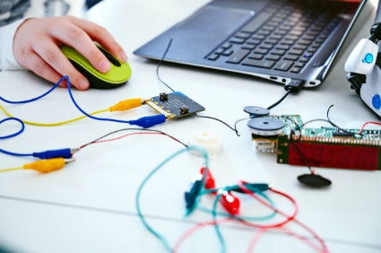  Students will make use of the new BBC Microbit computers to explore different programming environments and languages. They will learn how to use different inputs and triggers along with developing their understanding of programming concepts including handling variables and loops.  This term also coincides with the annual Safer Internet Day. Students will use this opportunity to discuss and explore a range of online safety issues including cyberbullying, identity theft and legal issues around copyright and computer misuse. |  | Pupils will study living in the wider world.  They will learn about diversity, prejudice and bullying.  They will also think about discrimination in a range of different forms.  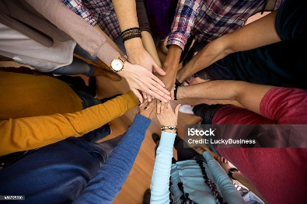
Geography & History | Art and DT |  | PE & Music |  | MFL
History  This term students will be examining the different methods of attacking and defending a medieval castle. We will then be moving onto looking at life in medieval England. This will include exploring the common types of crime and the different, and often barbaric punishments. As well as looking at the role of the church and religion in people’s lives. The unit will conclude with a case study on the Black Death.  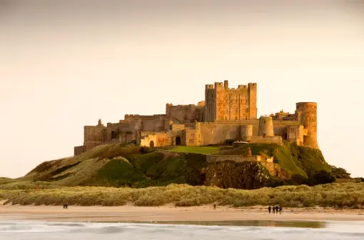  Geography  Young people will be able to understand the key processes in weather and climate.  We will be focusing on:  The process of cloud formation and the different types of cloud,  the different types of precipitation,  the causes and effects of high and low pressure fronts, the causes and effects of heatwaves, the different air masses that influence the UK’s weather systems and depressions and how these can be used to predict the movement of weather systems.  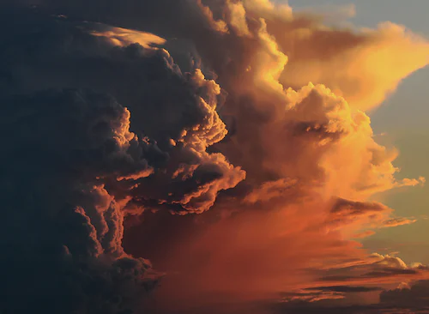 | Art  This term young people will be focusing on creating mixed media artwork including the use of digital art. They will increase their proficiency in the handling of different materials to create work based on Victorian Silhouette portraits, Personal Logos and Tags and then 3D digital art inspired by the style of ‘Minecraft’.  Students will use a range of techniques and media, including painting to record their observations in sketchbooks, journals and other media as a basis for exploring their ideas.  DT  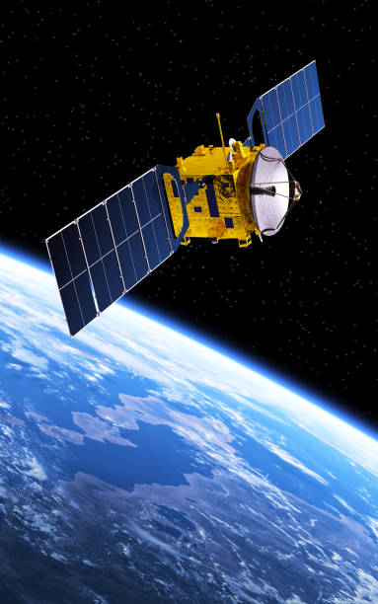  Students will be using research and exploration techniques to design and build a satellite choosing from a range of different complex materials. They will focus on how to solve and reformulate their design problems by communicating their ideas using annotated sketches, detailed plans, 3D mathematical modelling, oral and digital presentations and computer-based tools. Students will then evaluate and showcase their products.  Food Technology  Pupils will compare foods that are grown, processed, reared and caught. They will understand that seasons may affect the food available and be able to identify substances such as fruit and vegetables, carbohydrates, protein, dairy and fatty foods. They will learn how to prepare and cook a variety of predominantly savoury dishes safely and hygienically including the use of a heat source, and practice how to use a range of techniques such as peeling, chopping, slicing, grating, mixing, spreading, kneading and baking. |  | PE  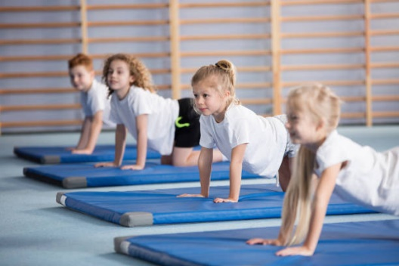In PE we are covering Gymnastics. Young people will learn how to use equipment and apparatus safely. They will explore moving in a variety of ways with control and care. Young people will be encouraged to copy, repeat, remember and create sequences independently, with a partner and as part of a small group. They will be given time to develop their leaderships skills and showcase their ideas to the rest of the class. Young people will be encouraged to compare their sequences with previous ones to identify areas of improvement.  Music:  Students will be creating a theme and variation composition on GarageBand using iPads. They will recap and explore the basic functions of this app, specifically further demonstrating their knowledge by adding in a new section and creating a rhythmic accompaniment using different instruments.  Students will explore the term 'Theme and Variation' itself, composing their own variation based upon a given theme. They will explore how this can be created both rhythmically and melodically.  Students will continue to explore and further broaden their knowledge of the musical dimensions by commenting on a wide range of elements when listening to various pieces of music. |  | MFL  In Spanish this term students will be working on naming, recognising and spelling up to 10 instruments in Spanish using the correct determiner.  They will also learn how to say I play an instrument in Spanish. We continue to work on improving memory skills and are starting to build a short phrase in Spanish using conjugated verb, 1st person of the verb to play (tocar), and definite determiner (la, el or los). Young people will be supported to choose and order these words accurately.  RE  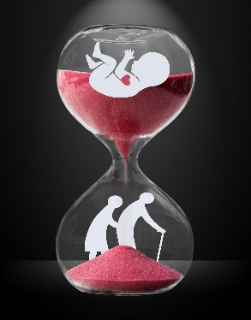  During our Big RE week pupils will be exploring the topic of Birth, life and death and what different religions believe happens during these very important parts of life. We will explore customs and rituals that celebrate birth, life experiences and death  from different world religions.

