Jade Base | This term we are learning about  “What can we learn from space?” |   What can we learn from space? | Our Change Maker principle, this term is 'Love’ | 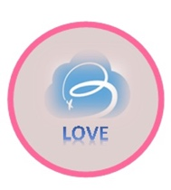

English | Maths | Science |  | Computing |  | PSHE/RSE
Story focus: The Tiger who came to tea A Long Way Home  - Introduce fantasy stories and discuss their characteristics.  - Read aloud an age-appropriate fantasy story, engaging the young people in discussions about the story.  - Identify and discuss story elements, such as characters, setting, problem and resolution.  Non-Fiction Newspaper  - Introduction to Newspapers  - The purpose of newspapers.  - Explore different sections such as headlines, articles, pictures, and captions.  - Explain the roles of journalists  - Creating News Articles   |   - Number quantity  - Confidently counting 1-20 and beyond  - Using objects to make a pattern  - Recognising small and big  Addition and Subtraction  - Addition – adding together  - Subtraction  - Add or subtract 1 or 2  - Fact families  Shape  - Recognise and name 3D shapes  - Patterns with 2D and 3D shapes  Multiplication and Division:  - Recognise and Make equal groups  - Multiplication sentences  - 2, 5, 10 times tables  - Multiplying and dividing by 2, 5 and 10. | Space:  Describe the Sun, Earth and Moon as approximately spherical bodies  - Describe the movement of the Earth, and other planets, relative to the Sun in the solar system  - Describe the movement of the Moon relative to the Earth and model this using equipment.  - Use the idea of the Earth’s rotation to explain day and night and the apparent movement of the sun across the sky.  - I can explain why night and day occur at different times in different places on Earth. |  | 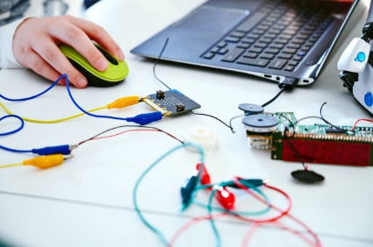  E-safety & Digital Citizenship  This year’s Safer Internet Day theme is “Together for a Safer Internet”  - We will raise awareness around the internet and how it has revolutionised our lives.  - How we communicate with each other through the internet and what the correct etiquette for this should be |  | Belonging to a community  - Learn about living in a community, the rules and laws within society.  - Learn about human rights.  - Begin learning about prejudice and discrimination  - Learn about rights and responsibilities e.g. the right to education, responsibility to learn.  - Show compassion for the environment and living things.  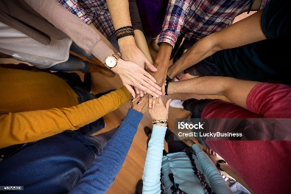
Geography & History | Art and DT |  | PE & Music |  | MFL
History  The Stuarts  Knows about the development of Church, state and society in Britain 1509-1745.  Young people will learn about:  - Charles I and his view on Monarchical rule.  - Oliver Cromwell and recall key pieces of information about who he was and what he was best known for.  - The Civil War and which main parties were included.  - The Great Plague and the Fire of London  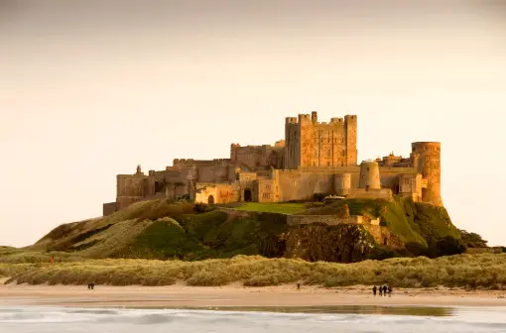  Geography  Geographical Skills and Fieldwork  Young people will try to:  - Use the 8 points of a compass  - Find Four and six-figure grid references  - Use symbols and a key to build their knowledge of the Uk and the wider world. | Art  - I can use IT to create art which includes my own work and hat of others  - I can use digital images and combine with other media in my art  DT  Make a space helmet and a space suit  - I can design a product and make sure that it looks attractive.  - I can follow a step-by-step plan, choosing the right equipment and materials.  - I can work accurately to measure, make cuts and make holes.  - I can select the most appropriate tools and techniques for a given task.    Food Technology  Chinese New Year  - Understand that food is grown, reared and caught in the UK, Europe and wider world.  - Familiarise ourselves with where food comes from.  - Understand that seasons affect the food available.  - Demonstrate confidence in how to use a range of techniques such as peeling, chopping, slicing, mixing, spreading, kneading and baking.  - Follow instructions step by step. |  | 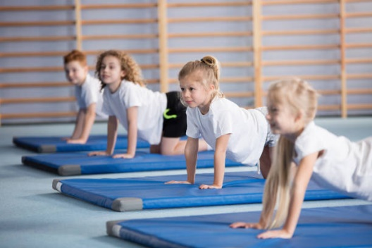  PE  In PE we will be exploring Gymnastics.  - Young people will learn how to use equipment and apparatus safely.  - They will explore moving in a variety of ways with control and care.  - Young people will be encouraged to copy, repeat, remember and create sequences independently and with a partner.  - They will be given time to showcase their ideas to the rest of the class.  Music:  - Students will be exploring the different sounds of boom whackers as well as performing in an ensemble.  - They will be exploring popular pieces of music, exploring the tone as well as key ensemble skills such as performing in time and with accuracy.  - Students will continue to develop their knowledge of the musical dimensions, commenting on these during listening activities. |  | MFL  Say how we are feeling.  Young people will learn to say 10 colours in Spanish.  Count from 1-10 in Spanish.  Listen carefully and repeat what we hear accurately.  RE  The children will be studying Life and Death across different religions.  -Christening  -Birth Rituals  -Different burials  -Afterlife

