Year 11 Overview of Learning Pupils from Amethyst Base | This term we are learning about  “What’s Beneath?” | 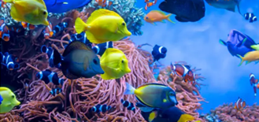 | Our Change Maker principle, this term is ‘Share’ | 

English – GCSE or Entry Level | Maths – GCSE or Entry Level | Science – GCSE or Entry Level | iMedia Cambridge Nationals | PSHE/RSE
Year 11 GCSE Pathway 3  As Year 11 progresses, we are entering a crucial phase in our young person’s academic journey, particularly in English Literature and English Language GCSEs. This term, our focus will be on consolidating and revising key concepts, texts, and skills essential for success in these examinations. Young people will engage in comprehensive review sessions, delving into literature texts, exploring themes, characters, and literary techniques, while also honing their analytical and essay-writing skills. In English Language, they will refine their comprehension abilities, practice writing for different purposes and audiences, and perfect their command of grammar, punctuation, and language conventions. Through targeted revision strategies, mock exams, and tailored feedback. We aim to ensure that our young people feel confident, prepared, and empowered to excel in their upcoming GCSE assessments.  Year 11 Entry Level Pathway 2  Identifying Writing Formats:  Introduce various writing  formats such as emails,  letters, reports, and  instructions. Discuss the  purpose, structure, and  language features of each  format.  Activity: Analyse sample  texts of different formats.  Discuss key elements and  practice identifying writing  styles.  This will include:  Punctuation  Capitalisation  Email etiquette  Letter writing | Y11 GCSE Pathway 3  This term is a mixture of examination practise and targeted revision teaching.  Every Thursday students will complete a cut down part paper which will be marked and analysed. From these topics will be identified that the students will work on during the next week of lessons.  Students will work in small target groups focusing on areas that need to be revisited to secure knowledge and methods.  Students are also completing their second set of Mock Examinations.  Year 11 Entry Level Pathway 2  Students will be learning to understand more complexed vocabulary surrounding maths symbols. Students will learn about many components of time and measure and have a go at applying this newfound language and knowledge into real life contexts. | Year 11 GCSE Pathway 3  Students will be commencing our Variation and Evolution topic. We will begin by looking at variation between species and its causes. We will explore how this variation is linked to Darwins’ Theory of Evolution by Natural Selection and compare this to Lamark’s and Wallace’s theories., evaluating their contribution to understanding evolution. We will look at fossils as evidence for evolution, how they may be formed and why scientists still can’t be certain how life on earth began. We will at how bacteria evolve rapidly and can therefore develop antibiotic resistance by natural selection. (Link to Defending against pathogens topic)  We will delve into Mendel’s experiments on pea plants and look at why the importance of Mendel’s discovery was not understood until after his death. (Revisiting chromosomes and structure of DNA).  Students will explore the selective breeding and genetic engineering of plants and animals, describing the steps involved and the benefits and risks.  Students will learn about clones and the cloning techniques used to clone plants and animals, evaluating the advantages and disadvantages as well as the ethical issues (SMSC).  We will look at how living things have been classified into groups depending on their structure and characteristics and discuss why the classification system has changed, looking at evolutionary trees how they demonstrate evolution between organisms within a species. | Students will work towards completing their second coursework unit; an interactive multimedia presentation promoting a summer sports club at a local leisure centre. They will learn how to create and embed a range of different media into their presentation and will produce all the necessary documentation required by the exam board. If this is completed before the end of term then they will begin the preparations for the summer examination unit  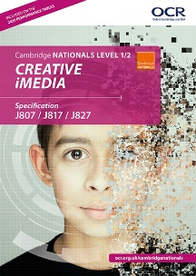 | PSHE/RSE Skills  The students will be learning about health and how this can be influenced negatively and positively. The children will look around diets and what lifestyle choices make a healthy life. The students will also begin to look in mental health, body image and how to best take care of these.  

BTEC Home Cooking Skills – Year 11 | Physical Education & Religious Education | Careers & Study Skills | Duke of Edinburgh Silver Award
Students will be finalising their skills in preparation for their final hand in date in May. They will continue to develop their independence when making and preparing a wide range of recipes as well as being able to choose a final recipe to prepare for their final piece of coursework.  Students will continue to develop a wide range of skills such as boiling, simmering, kneading, dicing, toasting and grilling.  They will also explore attractive food presentation in order to develop this further in the future! | Physical Education  In PE young people will be exploring invasion games. They will be encouraged to develop their technique and improve their performances using a variety of skills. Young people will be encouraged to analyse their own performances, comparing them to previous ones to demonstrate improvements. They will be encouraged to identify areas of sport they enjoy, researching local outside clubs they may wish to attend. Alongside this young people will continue to look at key sports leadership skills, learning about leadership qualities and styles together with the end aim of planning their own short activity to lead.  Religious Education  Pupils will learn about and celebrate the Sikh religion.  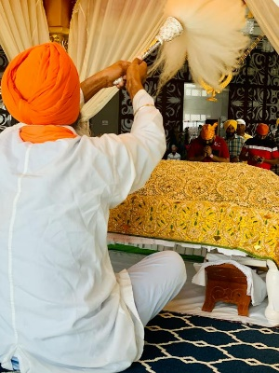 | Careers  Students will continue to explore a range of different revision and study skills in advance of their summer examinations. They will apply these skills to the work that they need to complete ahead of the examination window  Study Skills | Young people will continue to spend this half term focused on the Skill section, specifically cooking. They will begin to explore a variety of meal options that can be practiced before being transferred to being cooked on a Trangia. This will involve identifying what they like to eat, finding recipes, making a shopping list, going to our local supermarket and preparing the dish. As always it will continue to be filled with lots of fun and laughter alongside building independence ready for the expedition! They will set themselves personal challenges to push them outside their comfort zone to explore the unknown. Alongside all of this we continue to support young people to develop friendships, improve their self-esteem and build confidence.

