Year 10 Overview of Learning Pupils from Sapphire, Quartz & Amethyst Bases | This term we are learning about  “What’s Beneath?” | 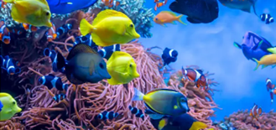  ccccc | Our Change Maker principle, this term is ‘Share’ | 

English – GCSE or Entry Level | Maths – GCSE or Entry Level | Science – GCSE or Entry Level | iMedia Cambridge Nationals or Performing Arts BTEC | PSHE/RSE & Personal Development
Year 10 GCSE English Flight Path Three  This term young people taking the English Language GCSE in May will consolidate and revise for the Eduqas English Language GCSE. Young people will focus on the skills crucial for success in this paper such as picking out key language techniques and analysing their impact on the reader. As well as this, the key focus of the term will be to aid young people in refining their ability to comprehend and analyse unseen texts; fostering critical thinking and honing effective writing strategies. Additionally, we will work with young people to help them to develop plans for the Creative Writing and Transactional writing component.  Y10 Entry Level English  Flight Path Two  Identifying Writing Formats:  Introduce various writing  formats such as emails,  letters, reports, and  instructions. Discuss the  purpose, structure, and  language features of each  format.  Activity: Analyse sample  texts of different formats.  Discuss key elements and  practice identifying writing  styles.  This will include:  Punctuation  Capitalisation  Email etiquette  Letter writing | Year 10 GCSE Pathway 3  This Term Students will be focusing on working with percentages. Students will learn how to calculate percentage increase and decrease and apply these to real life context such as sales and profits.  Students will learn about simple and compound interest; we will use this new knowledge deepen understanding of how this relates to bank accounts, wages, taxes and debt.  Year 10 Entry Level Pathway 2  Students will be learning to understand more complexed vocabulary surrounding maths symbols. Students will learn about many components of time and measure and have a go at applying this newfound language and knowledge into real life contexts. | Year 10 GCSE Biology Pathway 3  Students will begin their study of our Defences against Pathogens topic. They will be exploring the non-specific defense systems of the human body and the specific role of the immune system and white blood cells. We will be looking at vaccines in relation to the immune system, what they contain how they prevent disease. We will also be learning about antibiotics, when their use is appropriate and what is meant by antibiotic resistance.  We will delve into some early medicines and from what they were extracted and develop an understanding of why new drugs need to be tested. Students will learn about how monoclonal antibodies are produced and some ways in which monoclonal antibodies can be used. We will also be looking at some more plant diseases and investigating the effects of magnesium and nitrate ion deficiencies.  Year 10 ELC Science Pathway 2  Student will be continuing the Elements, Mixture and Compounds component of their qualification.  They will be exploring mixtures and how we can separate them, applying their knowledge of separating techniques to select methods from those given to separate simple mixtures including using chromatography to separate a mixture and identify the substances it contains.  We will also be looking at how reactive and unreactive metals are found on Earth., the obtaining of metals from ores and the social, economic and environmental impacts of mining ores and recycling metals. We will be delving into how the giant structure of metals and alloys relate to their melting points and how the properties of copper and aluminium make them useful for different purposes, linking this to a practical investigation into the conductivity of some  metals.  Polymers  Finally, students will learn about the structure of polymers, their properties and uses, why polymers cause litter and landfill sites to become full quickly and ways of disposing or recycling waste plastic. | Year 10 iMedia Cambridge Nationals (GCSE equivalent qualification)  Students will continue to work through their first coursework unit, centred around creating a graphic for a computer game loading screen. Students will learn a range of image editing techniques and produce the documentary evidence required by the exam board  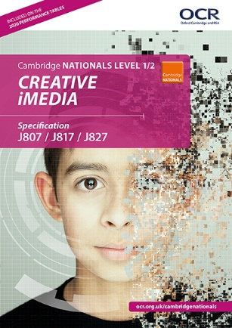  Year 10 Performing Arts (GCSE equivalent qualification)  Students will be developing their performance and ensemble skills, working towards their Unit 1 component.  Students will be choosing a song to perform as an ensemble as well as exploring some context around this piece.  They will develop their ability to perform in time as an ensemble as well as performing fluently and confidently ensuring that they are developing their ability to perform using musical dimensions (such as performing at the correct tempo and pitch etc). | PSHE/RSE Skills  The students will be learning about health and how this can be influenced negatively and positively. The children will look around diets and what lifestyle choices make a healthy life. The students will also begin to look in mental health, body image and how to best take care of these.    Personal Development

History – Year 10 GCSE | BTEC Home Cooking Skills – Year 10 | Physical Education & Religious Education | Careers & Study Skills | Duke of Edinburgh Silver Award
This term we will start the 2nd unit which is ‘Early Elizabethan England, 158-1588'  Students this term will look at the make-up of Elizabethan society and the structure of her government. They will also consider the challenges she faced upon her ascension to the throne, especially the religious divides in England between Catholics and Protestants. Students will analyse the threats both at home and from abroad and the role of Mary, Queen of Scots in numerous plots against Elizabeth I.  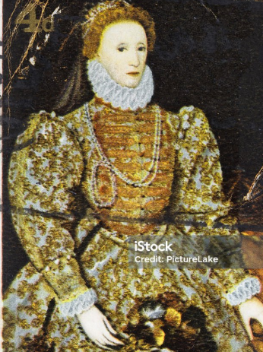 | Students will be finalising their skills in preparation for their final hand in date in May. They will continue to develop their independence when making and preparing a wide range of recipes as well as being able to choose a final recipe to prepare for their final piece of coursework.  Students will continue to develop a wide range of skills such as boiling, simmering, kneading, dicing, toasting and grilling.  They will also explore attractive food presentation in order to develop this further in the future! | Physical Education  In PE young people will be exploring invasion games. They will be encouraged to develop their technique and improve their performances using a variety of skills. Young people will be encouraged to analyse their own performances, comparing them to previous ones to demonstrate improvements. They will be encouraged to identify areas of sport they enjoy, researching local outside clubs they may wish to attend. Alongside this young people will continue to look at key sports leadership skills, learning about leadership qualities and styles together with the end aim of planning their own short activity to lead.  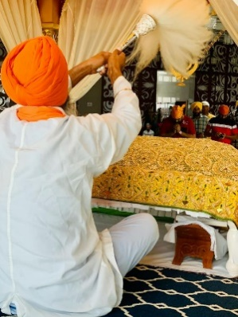  Religious Education  Pupils will learn about and celebrate the Sikh religion. | Careers  Students will continue to explore a range of different revision and study skills in advance of their summer examinations. They will apply these skills to the work that they need to complete ahead of the examination window  Study Skills | Young people will continue to spend this half term focused on the Skill section, specifically cooking. They will begin to explore a variety of meal options that can be practiced before being transferred to being cooked on a Trangia. This will involve identifying what they like to eat, finding recipes, making a shopping list, going to our local supermarket and preparing the dish. As always it will continue to be filled with lots of fun and laughter alongside building independence ready for the expedition! They will set themselves personal challenges to push them outside their comfort zone to explore the unknown. Alongside all of this we continue to support young people to develop friendships, improve their self-esteem and build confidence.

