Year 9 Overview of Learning Pupils from Turquoise, Sapphire & Quartz Bases | This term we are learning about  “What’s Beneath?” | 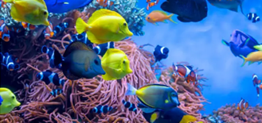 | Our Change Maker principle, this term is ‘Share’ | 
English | Maths | Science | Computing & Careers | PSHE/RSE
Y9 Group A  As part of their work towards their Functional Skills L1 and L2 qualifications, young people will focus on the writing component of the Pearson Functional Skills Level One English qualification. This focuses on honing young people’s ability to communicate effectively through writing in various contexts. Throughout this term, they will develop fundamental skills such as structuring clear and coherent texts, using language accurately to convey meaning, and adapting their writing style to suit different purposes and audiences.  Y9 Group B  This term in Year 9, our focus will be on enhancing your young person's functional English skills, particularly in the areas of dictionary skills, alphabetical order, and punctuation. Throughout the term, young people will hone their dictionary usage, learning how to efficiently navigate this essential resource to find word definitions, spellings, and pronunciations. Additionally, they will sharpen their ability to arrange words, phrases, and names in alphabetical order, a skill crucial for various academic and real-world contexts. Alongside this, young people will deepen their understanding of punctuation marks, ensuring that their written communication is clear, coherent, and grammatically correct. | Year 9 Group A  During this term students will be looking deeper into types of data and how this can be represented. We will look at the key differences between qualitive and quantative and then into discrete and continuous.  Students will look at different ways of representing data and make comparisons and draw conclusions.  We will finish this term by using table and charts to work out probabilities of events happening, constructing sample spaces and organising information using two way tables.  Year 9 Group B - ELC  Students are continuing to work on their Entry Level 1 course. Students will master their understanding of counting; this includes counting forward and backwards using different systems. Students will make comparisons between numbers and use this to order and group them them to fit required criteria.  We will end this term by working on securing effective methods of using the four operations in a range of question types. | Earth’s Resources  Students will explore renewable and non –renewable energy resources, and the importance making more use of renewable energy sources such as wind and solar energy, despite some of their disadvantages. They also will be delving into the formation of crude oil and the useful products that can be extracted from it.  We will be revisiting combustion as studied in plants and the carbon cycle in more detail, focusing on the chemical reaction, learning about what is required for fuels to burn and describing the difference between complete and incomplete combustion.  Students will be working scientifically to practically investigate ‘Which is the best fuel?’ They will be identifying the different variables in an investigation into the best fuel and explaining how to make sure their results are reliable.  They will accurately collect results, calculate the heat given out by each fuel and make conclusions based on their graph of their results.  We will be looking at how metals are found on Earth and describe metal extraction methods with a focus on environmental impact (SMSC). Students will explore how all the human activities discussed this half term have had an effect on the composition of the Earth’s atmosphere. We will discuss how we can this reduce human impact. This will lead us onto looking at why recycling some materials in particularly important and evaluate the efficacy of recycling. | Computing  Students will learn how to create, edit and manipulate digital images using a range of software tools. They will learn how to remove backgrounds, work with layers, add text and apply effects filters  This will provide a good foundation of knowledge for those students who have chosen to study the Creative iMedia option for one of their GCSEs    Careers & Enterprise:  . | The students will be learning about health and how this can be influenced negatively and positively. The children will look around diets and what lifestyle choices make a healthy life. The students will also begin to look in mental health, body image and how to best take care of these.  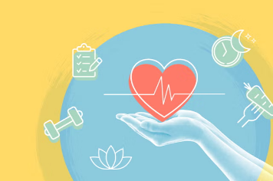

Geography & History | Art and DT | PE & Music | MFL & RE | Duke of Edinburgh
History  This term students will start with a mini topic looking at the role of women in Edwardian Britain with lessons focused on the topical duties of women in the upper, middle and working class. They will then look at the role of the Suffergists and Suffergettes in campaigning for the franchise for women, include the act of Emily Davidson at the 1913 derby.  After that we will start the larger topic of World War One. This term students will look at the facts that contributed to the outbreak of war in 1914, as well as the Schlieffan Plan and the German invasion of Belgium. We will also consider the effectiveness of propaganda in getting men to volunteer to fight  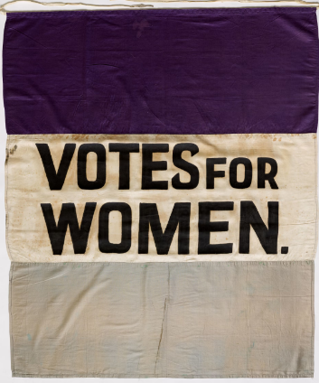  Geography  This term students will be extending their locational knowledge and deepen their spatial awareness of the world’s countries using maps of the world to focus on Africa, focusing on environmental regions, including polar and hot deserts, key physical and human characteristics, countries and major cities.  This term will include an introduction to the African continent, an overview of the physical geography and the human influence on the region and a focus on Ghana and Kenya  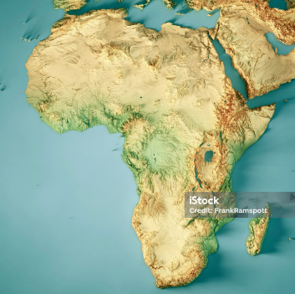 | Art  Woodwork  Students will explore the use of epoxy resin as a resistant material. They will learn how to measure, weigh and cast their projects and polish them to a good finish. They will consider the health and safety implications of working with this material  OR  Food Technology  Students will be preparing for following and reading more complex recipes. They will be working independently to produce a wide range of sweet and savoury dishes, as well as continuing to build and develop their skillset further to support them in the future.  Students will ultimately be more confident in the kitchen and be able to adapt to new recipes by utilising their skills further. | PE  In PE young people will be exploring invasion games. They will use a range of tactic and strategies to overcome opponents through team games. Young people will be encouraged to analyse their own performances, comparing them to previous ones to demonstrate improvements. They will be encouraged to identify areas of sport they enjoy, researching local outside clubs they may wish to attend.  Music  Students will be exploring a wide variety of pieces from musicals and exploring how musical dimensions have been manipulated to create an atmosphere and mood within the music.  They will perform pieces from ‘The Greatest Showman’, ‘We Will Rock You – The Musical’ and ‘Shrek The Musical’. Students will explore and continue to improve their technique on keyboard or guitar, as well as their ability to perform in time and fluently.  Students will also recognise and listen to instruments from the four instrument families as well as exploring timbres and different sounds of each instrument. | Spanish  RE  Personal Development | Young people will spend this half term continuing to focus on Physical and Skill. They will explore these two sections completing a variety of activities. As always it will continue to be filled with lots of fun and laughter alongside building independence, developing fitness and essential skills for life and the expedition. They will set themselves personal challenges to push them outside their comfort zone to explore the unknown. Alongside all of this we continue to support young people to develop friendships, improve their self-esteem and build confidence.

