Year 8 Overview of Learning Pupils from Sapphire & Quartz Bases | This term we are learning about  “What’s Beneath?” | 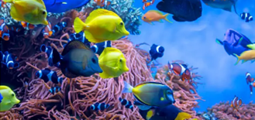 | Our Change Maker principle, this term is ‘Share’ | 

English | Maths | Science | Computing & Careers | PSHE/RSE
This term, young people in Year 8 will continue to delve into the world of "Poetry, Myths, and Monsters" using the poetry anthology 'Falling Out of the Sky.' Throughout this exploration, young people will develop a keen understanding of various poetic techniques and learn to recognise them within poems. Some young people will then extend this knowledge and discuss how these techniques impact readers. The topic will also encourage thoughtful discussions on characters and settings in mythical contexts, extending young people’s imaginations and fostering critical thinking. As a culmination, young people will have the opportunity to channel their insights into creating their own poems inspired by ideas of Myths and Legends.  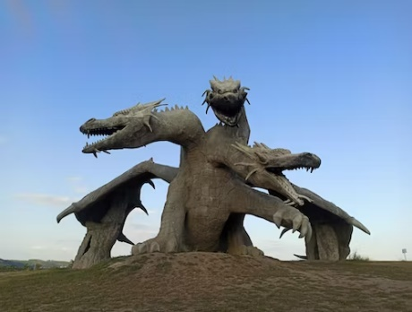 | Year 8 Group A  During this term students will be looking deeper into types of data and how this can be represented. We will look at the key differences between qualitive and quantative and then into discrete and continuous.  Students will look at different ways of representing data and make comparisons and draw conclusions.  We will finish this term by using table and charts to work out probabilities of events happening, constructing sample spaces and organising information using two way tables.  Year 8 Group B  This term students will be working on finding the area and perimeter, from counting squares to compound shapes. Students will learn about the connection between different shapes and how the areas relate. Students will then extend this foundational understanding to real life contexts.  We will finish this module by finding volume of shapes, by counting cubes as well as using the formulas. | Earth’s Resources  Students will explore renewable and non –renewable energy resources, and the importance making more use of renewable energy sources such as wind and solar energy, despite some of their disadvantages. They also will be delving into the formation of crude oil and the useful products that can be extracted from it.  We will be revisiting combustion as studied in plants and the carbon cycle in more detail, focusing on the chemical reaction, learning about what is required for fuels to burn and describing the difference between complete and incomplete combustion.  Students will be working scientifically to practically investigate ‘Which is the best fuel?’ They will be identifying the different variables in an investigation into the best fuel and explaining how to make sure their results are reliable.  They will accurately collect results, calculate the heat given out by each fuel and make conclusions based on their graph of their results.  We will be looking at how metals are found on Earth and describe metal extraction methods with a focus on environmental impact (SMSC). Students will explore how all the human activities discussed this half term have had an effect on the composition of the Earth’s atmosphere. We will discuss how we can this reduce human impact. This will lead us onto looking at why recycling some materials in particularly important and evaluate the efficacy of recycling. | Computing  Students will learn how to create, edit and manipulate digital images using a range of software tools. They will learn how to remove backgrounds, work with layers, add text and apply effects filters    Careers and Enterprise  This half-term young people will continue to learn the importance of a variety of skills needed for the world of work. They will complete practical activities along with research tasks to develop these skills personally. Some of the skills include, communication, teamwork, leadership, resilience, organisation, creativity and more. | The students will be learning about health and how this can be influenced negatively and positively. The children will look around diets and what lifestyle choices make a healthy life. The students will also begin to look in mental health, body image and how to best take care of these.

Geography & History | Art and DT | PE & Music | MFL & RE
History  This term students will start with a mini topic looking at the role of women in Edwardian Britain with lessons focused on the topical duties of women in the upper, middle and working class. They will then look at the role of the Suffergists and Suffergettes in campaigning for the franchise for women, include the act of Emily Davidson at the 1913 derby.  After that we will start the larger topic of World War One. This term students will look at the facts that contributed to the outbreak of war in 1914, as well as the Schlieffan Plan and the German invasion of Belgium. We will also consider the effectiveness of propaganda in getting men to volunteer to fight  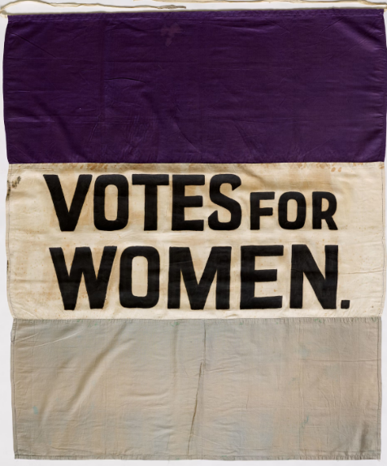  Geography  This term students will be extending their locational knowledge and deepen their spatial awareness of the world’s countries using maps of the world to focus on Africa, focusing on environmental regions, including polar and hot deserts, key physical and human characteristics, countries and major cities.  This term will include an introduction to the African continent, an overview of the physical geography and the human influence on the region and a focus on Ghana and Kenya  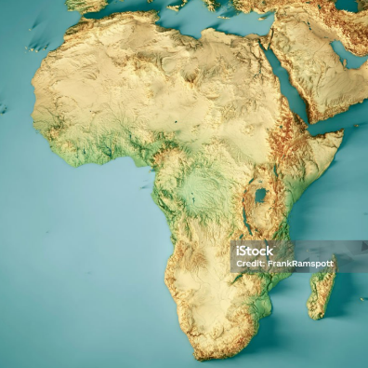 | Art  Woodwork  Students will develop their skills in measuring, marking, cutting and assembling wood through a variety of practical projects. They will learn about the different types of wood joint and jointing methods. They will consider how to draw detailed deigns for their own projects  OR  Food Technology  Students will be developing their independence by following a wide range of recipes which develop their culinary skills. They will also learn new skills such as simmering and boiling in order to further their knowledge.  Students will be able to cook both sweet and savoury dishes confidently in order to gain important life skills. | PE  In PE young people will be exploring invasion games. They will use a range of tactic and strategies to overcome opponents through team games. Young people will be encouraged to analyse their own performances, comparing them to previous ones to demonstrate improvements. They will be encouraged to identify areas of sport they enjoy, researching local outside clubs they may wish to attend.  Music  Students will be exploring a wide variety of pieces from musicals and exploring how musical dimensions have been manipulated to create an atmosphere and mood within the music.  They will perform pieces from ‘The Greatest Showman’, ‘We Will Rock You – The Musical’ and ‘Shrek The Musical’. Students will explore and continue to improve their technique on keyboard or guitar, as well as their ability to perform in time and fluently.  Students will also recognise and listen to instruments from the four instrument families as well as exploring timbres and different sounds of each instrument. | Spanish  Students will continue to learn a range of new Spanish vocabulary and incorporate this into simple conversational sentences. They will develop their speaking, listening and writing skills in Spanish    RE  Personal Development  We will continue to look at the importance of living a healthy active lifestyle. This topic will link to developing road safety skills in our local community. Young people will continue to explore healthy dishes and will plan a route to access a local supermarket to purchase the ingredients to prepare a dish as independently as possible. For this to happen young people will continue to develop research skills to find a nearby supermarket, recipe and create a shopping list, using mathematical skills to understand prices and to work out how much the dish is going to cost.

