Ruby Base | This term we are learning about  “What’s Beneath?’ | 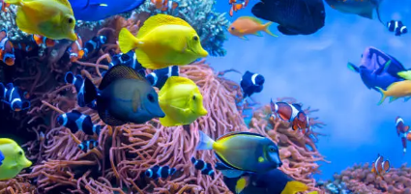 | Our Change Maker principle, this term is ‘Share’ | 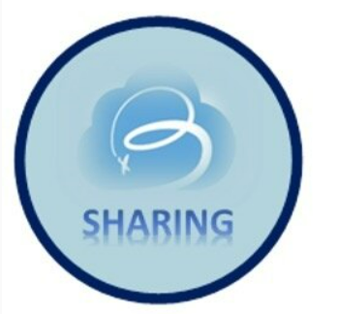
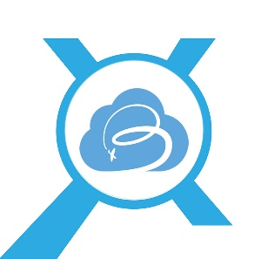
English |  | Maths | Science |  | Computing | PSHE/RSE
Text- Fantastic Mr Fox  Non chronological report writing  Instruction writing- E.G “How to catch Fantastic Mr Fox”  Focusing on purpose and structure of instructions  Extracting information from the text  Answering retrieval questions and predicting what might happen next.  To be able to draft write by composing a sentence orally before writing it.  Start sentences with capital letters, use finger spaces to separate words and end sentences with full stops.  Extending sentences by using more than one clause and using a range of conjunctions such as when, if, because and although  Develop our understanding of vocabulary and unfamiliar words. |  | Multiplication- Writing and calculating mathematical statements for multiplication and division  Learning to multiply 2-digit numbers by 1 digit with no exchange  Multiplying 2 digit by 1 digit numbers with 1 exchange  Counting in 2,s 5,s 10,s and applying this to number sequences  Recognising multiplication facts and tables of 2s, 3s, 4s, 5s and 10s  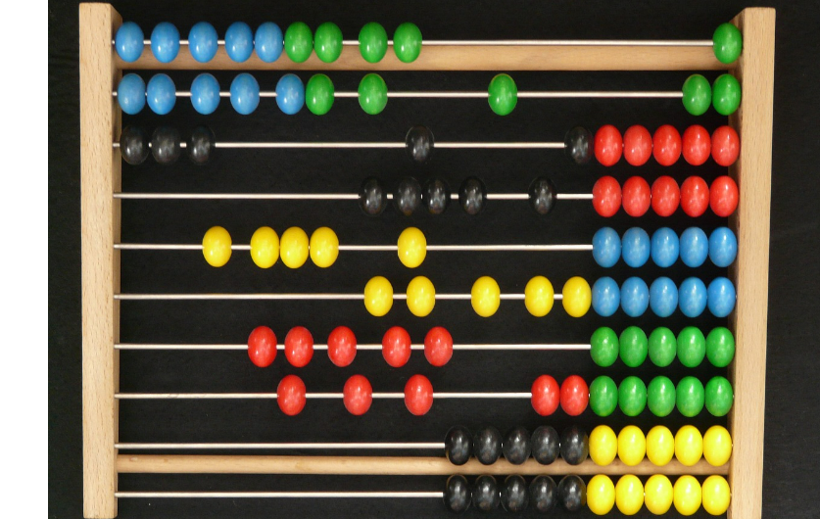 | Properties and everyday materials  To investigate, compare and group together a range of materials based on hardness, flexibility and transparency  Investigating electrical and thermal conductors  Describing how some materials will dissolve to form a solution  Working scientifically to carry and investigations and ensuring the test are fair and valid  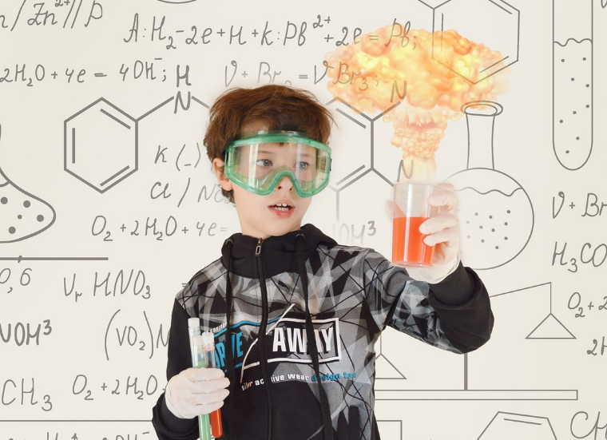 |  | Using technology safely and respectfully  Using a range of software to create a appealing advert  E-Safety and Digital Citizenship-  Exploring how the internet impacts daily lives  Learning how and why we communicate through electronic devices and the safety aspects of talking online  Learning the importance of reporting concerns online | Understand job sectors and the importance of maintaining a job  Investigating money and the value it has on society  Learning skills needed to maintain a job such as teamwork, communication and positivity  Discussing money management in terms on budgeting and saving  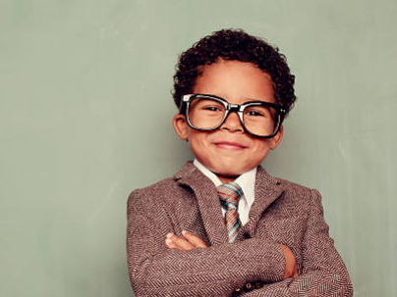
Geography & History | Art and DT |  |  | PE & Music |  |  | MFL & RE
In Geography we are:  Focusing on Natural Disasters including Volcano eruptions, Tsunamis and Earthquakes  Students will be investigating:  How Earthquakes are created and the impact this causes.  How Volcanoes erupt and the impact this causes.  Students will also look at some of the most famous Volcanoes in the world and their locations  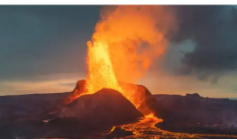  In History we are learning about the Victorians:  To be able to sequence the main events of the Victorian Period  Investigating the inventions that happened during the Victorian Era  To learn and understand the importance of transport in the Victorian Era and compare this to transport today  Comparing Victorian lifestyles to our lives today focusing on all aspects such as school life and jobs.  Investigating the industrial revolution and the effect this had on the country. 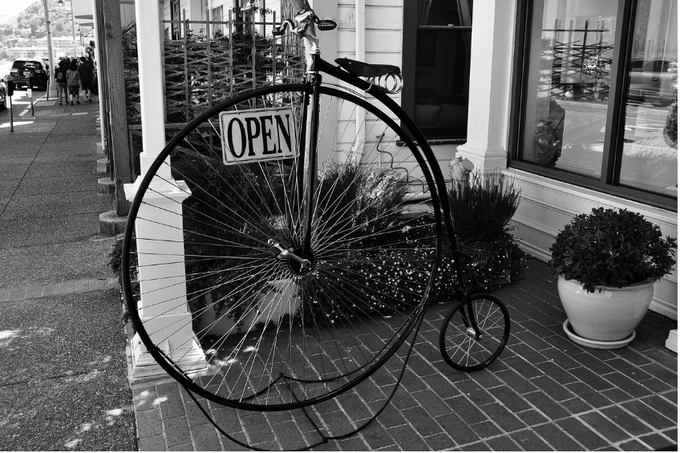 | In Art we are learning to:  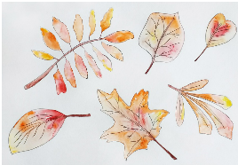  Recreate seasons of the year using a range of art techniques including water colour, chalk, pastels and sketches.  Use a range of techniques to create different art effects such as line and texture  To use a range of techniques to record observations, in sketchbooks, journals and other media for exploring ideas  Use correct terminology when discussing art to demonstrate knowledge  In Design and Technology, we are:  Designing and making a range of underwater products such as submarines, periscopes.  Designing and making a submarine out of a range of self-chosen materials, enabling it to float.  Students will be able to evaluate their product based on meeting the design criteria and appearance  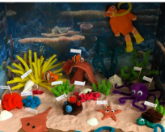  Using a research proposal and design to create a finished product  Exploring materials and tools  Learning to follow a step by step plan and choosing the right equipment to make an appealing product |  |  | In PE young people will learn to use equipment safely. They will spend time working independently, with a partner and as part of a small group. Young people will follow rules and learn about tactics of games. They will explore games that require throwing, catching, rolling and kicking. They will explore passing, shooting and dribbling. Some will begin to look at the best space to be during a game to support team-mates and cause problems for the opposition. Young people will be encouraged to compare performances to achieve their personal best.  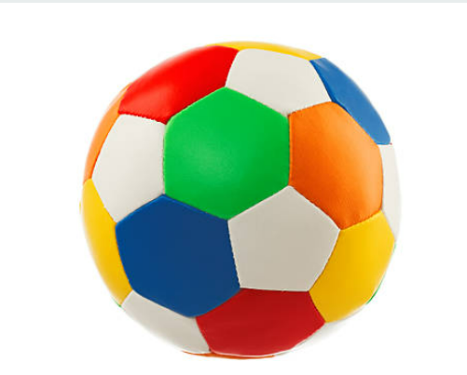  Music-  Students will be recapping their knowledge of musical instruments from each of the four families (strings, percussion, woodwind and brass). They will be listening to different sounds and exploring the different timbres and pitch of each instrument.  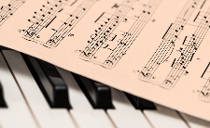  Students will then be developing their knowledge of musical dimensions including tempo, dynamics and instruments when listening to three key pieces of music. They will perform traditional pieces of music on the keyboard independently as well as perfecting their technique in their right hand. |  |  | In Spanish we are learning about transport:  Students will be able to recall up to 5 different types of transport in Spanish  Students will start to use the correct pronunciation when speaking  The young people will be able to start use the name of a type of transport in a sentence    RE  The celebration of Sikhism

