Pearl Base | This term we are learning about  “What’s Beneath? | 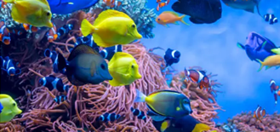  What’s Beneat | Our Change Maker principle, this term is 'Share’ | 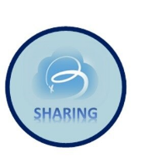

English | Maths | Science |  | Computing |  | PSHE/RSE
This half term, Pearl Class will continue reading: Wolf Wilder by Katherine Rundell.    Pupils will develop an appreciation and love of reading, and read increasingly challenging material independently. They will develop creative expression.  They will write accurately, fluently, effectively and at length for pleasure and information. They will achieve this by exploring the setting and characters, themes and symbolism.  They will be introduced to point, evidence, explain (PEE) paragraphs and learn to successfully analyse information learnt through the medium of newspaper writing. | Pupils will learn about multiplication, division and fractions, specifically looking at cube numbers and multiplying and dividing by 10, 100 and 1,000.  They will also study equivalent, improper and mixed fractions, ordering, adding and subtracting them.  Some pupils will also learn about equality and equivalence, place value and ordering integers and decimals.   | Pupils will explore renewable and non-renewable energy resources, and the importance making more use of renewable energy sources such as wind and solar energy, despite some of their disadvantages. They also will be delving into the formation of crude oil and the useful products that can be extracted from it.  We will revisit combustion in more detail, focusing on the chemical reaction, learning about what is required for fuels to burn and describing the difference between complete and incomplete combustion.  Students will be working scientifically to practically investigate ‘Which is the best fuel?’  Young people will be look at how metals are found on Earth and describe metal extraction methods with a focus on environmental impact. They will explore how human activities have had an effect on the composition of the Earth’s atmosphere. We will discuss how we can reduce human impact. This will lead us onto looking at why recycling materials is important and evaluate the efficacy of recycling. |  | Students will learn how to create, edit and manipulate digital images using a range of software tools.  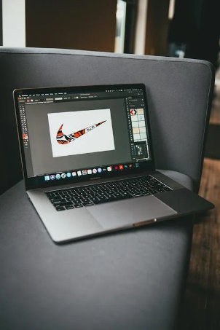  They will learn how to remove backgrounds, work with layers, add text and apply effects filters in order to create their own digital image. |  | Pupils will study emotional well-being, healthy lifestyles and influences.  They will discuss mental health and emotional wellbeing, including body image and coping strategies.  They will learn about healthy routines, diet, exercise and lifestyle balance.  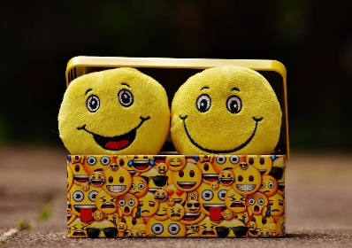
History & Geography | Art and DT |  | PE & Music |  | MFL & RE
History  Pupils will look at medieval kings under fire. They will participate in a series of lessons looking at how the absolute rule of kings began to be challenged. Students will look at the events such as the death of Thomas Becket, the sign of Magna Carta, the legend of Robin Hood and the Peasants Revolt.  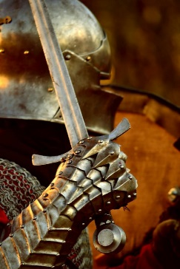  Geography  Pupils will learn about physical geography relating to weather and climate, including the change in climate from the Ice Age to present day.  They will focus on: storms, climate graphs, UK climate and extreme climates.   | Art  Pupils will be focusing on their drawing techniques including shading and the use of tone. They will zoom in on the art work of multi-media artist Louis Jover. They will create a piece of art imitating Jover’s style and artistic techniques.  Young people will use a range of techniques and media, including painting to record their observations in sketchbooks, journals and other media as a basis for exploring their ideas.    DT  Pupils will be using research and exploration techniques to design and build a diorama of a Coral Reef, choosing from a range of different materials. They will focus on how to solve and reformulate their design problems by communicating their ideas using annotated sketches, detailed plans, 3D mathematical modelling, oral and digital presentations and computer-based tools. Students will then evaluate and showcase their product.  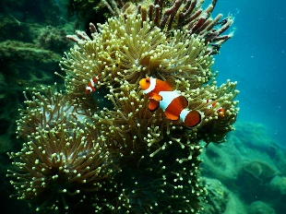  Food Technology  Pupils will be able to identify foods associated with specific bacteria and methods of reduction, including methods of reducing the risk of cross contamination.  They will follow the Eatwell guide and create a healthy balanced diet.  Young people will understand the process of caramelisation.  They will also be able to discuss raising agents and determine which are used within a recipe.  Pupils will be able to identify the correct method of cooking for all recipes. They will be able to effectively learn and use frying, baking, grilling, toasting and boiling methods.   |  | PE  Pupils will learn passing, dribbling and shooting techniques. They will explore tactics of a game to attack and defend. They will work as part of a team, communicating a plan and following rules. They will compare their performances with previous ones, demonstrating improvement to achieve their personal best. Some will lead others in a game situation, explaining rules of the game. Some young people will progress to umpiring a game.  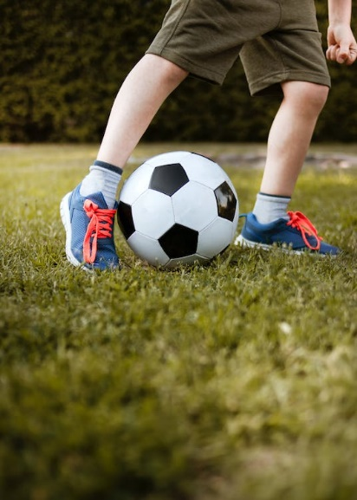  Music  Students will be recapping their knowledge of musical instruments from each of the four families (strings, percussion, woodwind and brass). They will be listening to different sounds and exploring the different timbres and pitch of each instrument. Students will be broadening their use of musical vocabulary, particularly the musical dimensions where they will be able to comment on the pitch, texture, timbre, dynamics and instruments when listening to a piece of music.  Students will be exploring three key pieces from musicals - particularly The Greatest Showman, We Will Rock You and Matilda. They will explore how musical dimensions have been manipulated to influence different atmospheres and moods within a piece of music. They will perform each of these key pieces on either keyboard or guitar, working independently to perfect their technique in their right hand as well as performing confidently and fluently.  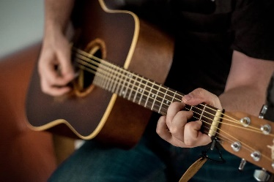 |  | MFL  Pupils will practise basic phonic knowledge for pronunciation and spelling of Spanish words.  They will work on improving memory skills through a variety of interactive activities.    RE  Pupils will learn about and celebrate the Sikh religion.  

