Jade Base | This term we are learning about  “What’s beneath?” | 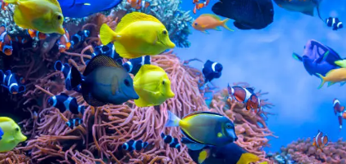 | Our Change Maker principle, this term is 'Share’ | 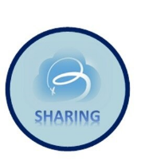
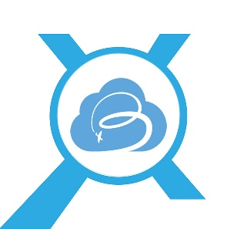
English | Maths | Science |  | Computing |  | PSHE/RSE
Students will be:  Studying the story, “The Rainbow Fish.” We will be describing the characters, the ocean setting and talking about the moral of the story, linked to the change maker, ‘share.’  Sequencing photographs of our visit to The Deep and writing a recount, using time openers.  Reading the non-fiction text, ‘First Big Ocean’ and learning about sea creatures. We will write our own sentences/ short paragraphs based on our research from the text.  Listening to the story, ‘Bog Baby,’ then making their own Bog Baby before writing a short description of it and a set of instructions about caring for their Bog Baby.  We will be working on the correct formation of all uppercase and lowercase letters, using conjunctions (eg, and, but, so, because) to extend our sentences, using punctuation, including full stops, exclamation marks and question marks and using clear finger spaces. | Students will be:  Using addition to learn number bonds.  Using subtraction to find the difference between numbers.  Completing missing number calculations.  Learning about measurements including  length and height using centimetres and metres.  Then moving on to mass, capacity and temperature.  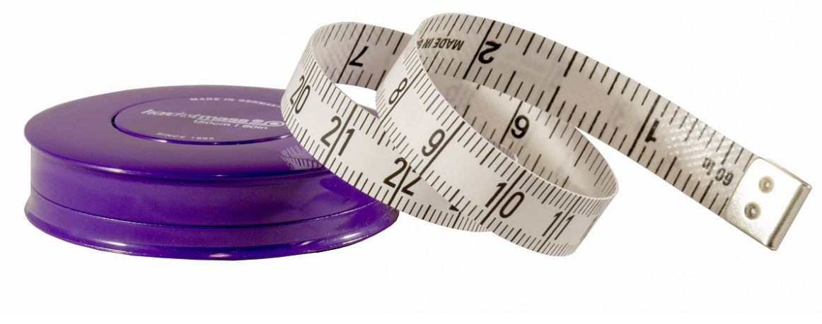 | This Half Term we will be learning about different materials, their properties and uses.  Students will be able to:  Distinguish between an object and the material it is made from.  Make a prediction.  Perform simple tests.  Use their observations to answer simple questions.  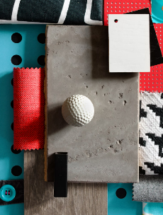  Sort objects 3 ways. |  | Students will:  Be able to use technology safely and respectfully, keeping personal information private; and identify where to go for help and support when they have concerns about content or contact on the internet or other online technologies.  Recognise common uses of information technology beyond school.  Use technology purposefully to create, organise store, manipulate and retrieve digital data. |  | Students will learn:  That everyone has different strengths and how to recognise their own strengths.  That jobs help people to earn money to pay for things.  Some of the strengths and interests that people might need to do different jobs.  That there are different jobs that people they know or people who work in the community do.
Geography & History | Art and DT |  | PE & Music |  | MFL
History  This Half Term we will be learning about the Victorians.  Students will:  Learn about the life of Queen Victoria and when she reigned.  Learn about what it was like to be a child in Victorian times, including going to work and school life.  Learn about what houses were like in the Victorian times.  Learn about seaside holidays in Victorian times and how they compare to holidays today.  Geography  Students will:  Learn about the layers of the Earth.  Learn about natural disasters including volcanoes; naming parts of a volcano and learning about how it erupts.  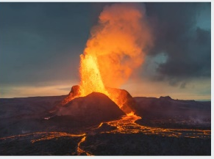 | Art  Students will:  Learn about and explore seasonal colour changes.  Learn how to colour match,  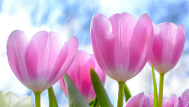  Create observational drawings.  Be able to use a range of sketching skills.  DT  Students will be:  Designing and making boats.  Investigating existing toy boats, including the designs and different materials used.  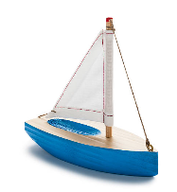  Selecting and using tools safely and appropriately.  Using our own designs to make a finished product.  Evaluating and presenting our finished boats, including testing whether they float.  Food Technology  Students will:  Be able to cut, spread and slice food safely to make a healthy dish.  Design and make sandwiches, smoothies, fruit salad, pizza and Easter treats. |  | PE  Young people will learn to use equipment safely. They will spend time working independently, with a partner and as part of a small group. Young people will follow rules of games that require throwing and catching with one and two hands, rolling and kicking. They will explore passing, dribbling and shooting. Young people will learn to copy and repeat actions to play games.  Music:  Young people will produce a samba performance and be able to hold a simple rhythmic pattern.  Young people will explore and perform using percussion instruments.  Young people will explore key musical dimensions such as tempo and rhythm.  Young people will recap musical notation. |  | MFL  Pupils will learn 7 modes of transport in Spanish (nouns and definite articles).  Recall numbers 1-5 and the colours yellow, red, green, orange & blue more easily in Spanish.  Learning to listen carefully and repeat what we hear with improving accuracy.  RE  This Half Term in RE we will be learning about Sikhism and will be visiting a Gurdwara.  

