Opal Base | This term we are learning about  “What’s Beneath?” | 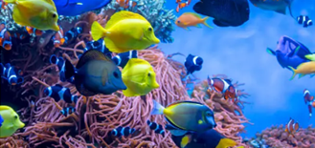 | Our Change Maker principle, this term is 'Share’ | 
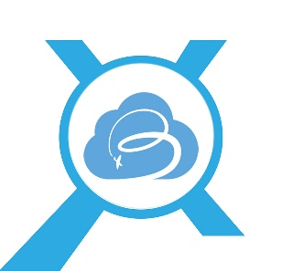
English | Maths | Science |  | Computing |  | PSHE/RSE
SATs preparation  Reading  Fiction, Non-fiction and Poetry  Focus on key reading skills:  Retrieval, inference, prediction, vocabulary, sequencing  Spelling, Punctuation and Grammar  SATs prep  Writing  SATs prep  Fiction  Short stories  Non-fiction  Work on 'Travel Writing' creating your own travel guides and persuasive pieces.  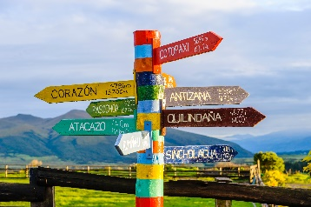 | SATs prep  Arithmetic  Place Value  Addition, subtraction, multiplication, division  Fractions  Addition, subtraction, multiplication, division, simplifying and converting  Decimal, percentages  Reasoning  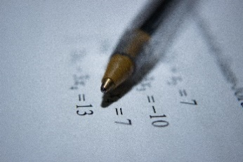 | What’s beneath?  Investigate, compare and group together everyday materials based on their properties, including their hardness, solubility, transparency, conductivity (electrical and thermal), and response to magnets.  * Describe how some materials will dissolve in liquid to form a solution.  * Work scientifically to investigate and give reasons, based on evidence from comparative and fair tests, for the particular uses of everyday materials, including metals, wood and plastic. |  | E-safety & Digital Citizenship  Basics of photo manipulation using proper image editing software  Use photopea.com or GIMP to learn how to edit a photograph:  - Remove backgrounds  - Apply filters  - Work with layers  - Apply special effects   |  | The students will learn about the internet and that everything shared online leaves a digital footprint.  They will explore different types of media and their different purposes e.g. to entertain, inform, persuade or advertise and how organizations can use personal information can be used to persuade you to buy something.  We will look closely into how to safely search online and that search results are ordered by popularity as well as looking at recognizing unsafe or suspicious content online and how to report this.
Geography & History | Art and DT |  | PE & MFL |  | Music & RE
History  The Victorians  Students will learn about:  - To learn about a key person in the Victorian era  - To compare and contrast Victorian days to present  - Inventions created in the Victorian era  Geography  Natural Disasters  Students will be able to:  - To discover what's underground  - How are volcanoes formed  - How do volcanoes affect people's lives?  - What causes Earthquakes | Art  Students will be using a variety of skills to create a detailed piece of artwork.  Skills focused on will be:  - Textures  - Pattern  - Colour  - Line  - Tone  - Printing  DT  To make a model of a specific ocean habitat.  Food Technology  Food Safety  Hygiene  Vegetable soup, Pizza pinwheels, Easter buns.  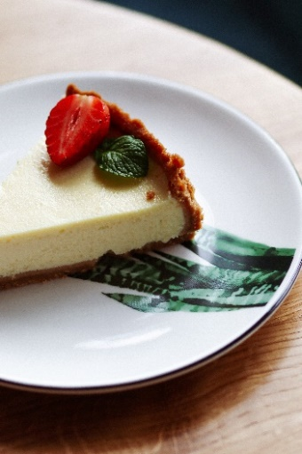 |  | PE  Young people will learn passing, dribbling and shooting techniques.  They will explore tactics of a game to attack and defend.  Young people will work as part of a team, communicating a plan and following rules. They will compare their performances with previous ones, demonstrating improvement to achieve their personal best.  Some will lead others in a game situation, explaining rules of the game.  Some young people will progress to umpiring a game.  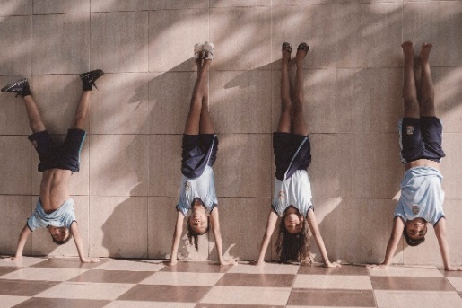  MFL  Pupils will learn basic Spanish and begin to communicate with peers.  Focuses on:  Basic commands and speech  Fruits, Vegetables, Seasons  Shapes, Animals  Recognise, remember and spell 10 action verbs in Spanish. |  | Music  - Students will be recapping their knowledge of musical instruments from each of the four families (strings, percussion, woodwind and brass). They will be listening to different sounds and exploring the different timbres and pitch of each instrument.  - Students will be broadening their use of musical vocabulary, particularly the musical dimensions where they will be able to comment on the pitch, texture, timbre, dynamics and instruments when listening to a piece of music.  - Students will then perform three traditional pieces of music on either keyboard or guitar, working independently to perfect their technique in their right hand and working towards a confident and fluent performance of one of these pieces.  RE  - A Sikh celebration  - Learning about it means to be a Sikh  - Festival of Holi

