Ruby Base  Overview of Learning | This term we are learning about  “Can all change be good?” |  | Our Change Maker principle,  this term is 'Future’ | 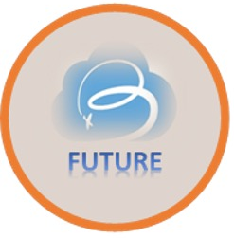

English | Maths | Science |  | Computing |  | PSHE/RSE
The focus of our English this half term is reading for pleasure! Young people will be reading a variety of books and joining in with whole class texts.  We will be specifically focusing on:  Fostering a love of reading  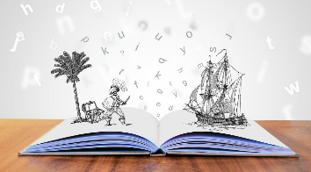  Developing comprehension and critical thinking skills  Independent and group reading  Looking at a variety of genres and authors  Enhancing vocabulary and language through reading | Telling time:  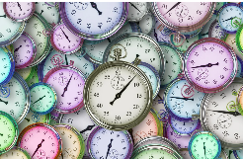  Being able to read O’clock half past, quarter to and quarter past  Telling the time to the hour  Recognising 5-minute intervals  Minutes in a hour  Hours in a day  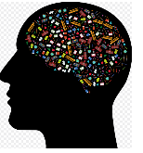  Shape:  Recognising common shapes  Turns and angles including right angles and comparing different angles  Measuring shapes accurately  Drawing shapes accurately  Focusing on horizontal, vertical, perpendicular and parallel lines | In Science the focus will be on porperties and changes in materials investigating:  Reversible and irreversible changes  Soluble and insoluble  Disolving and mixing  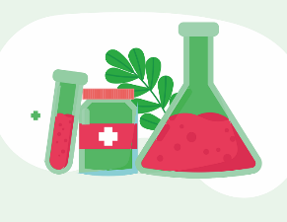  Safe chemical recations |  | The focus in computing will be on laptop and typing skills specifically:  Increasing speed  Increasing accuracy  Ensuring fingers are on the correct keys to help with fluency  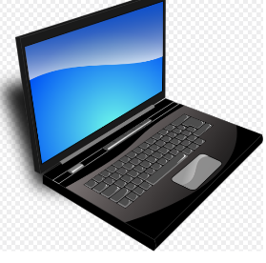  Typing sentences including capital letters and punctuation |  | The focus in PSHE this half term is being healthy, keeping safe and growing and changing specifically focusing on:  Recognising what makes us unique  Personal identity, qualities and mental wellbeing  The process of growing older physical and emotional changes  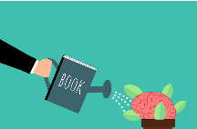  How rules and age restrictions keep us safe  Managing risks at home and within the community
Geography & History | Art and DT |  | PE & Music |  | MFL
History:  In History we are learning about WW2 including:  Understanding how and why WW2 started and the countries/ people involved  Researching weapons and methods of attack used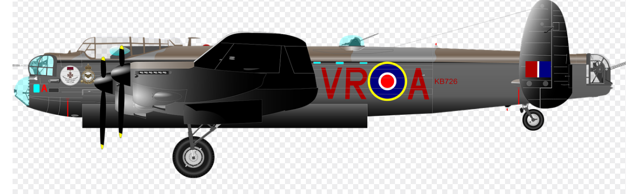  Learning what D-day was and why it is important  Understanding all about VE day and the celebrations around it  Focus on home front and the impact of WW2 on civilization  Researching Anderson shelters and the purpose and impact of them  Investigating what rationing was and the effects this caused  Understanding all about evacuation including who and what was involved in the process  Geography:  In Geography we are:  Focusing on Physical features including:  Using correct language and geographical words to describe physical features including rivers, mountains, hills, and coasts  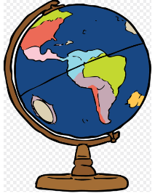  Being able to identify physical features in an atlas  Comparison of coasts and inland features  Describing the process of water movement in rivers | Art  In Art we are focusing on drawing and painting specifically:  Producing art in the style of another artist  Mixing paint to create primary and secondary colours  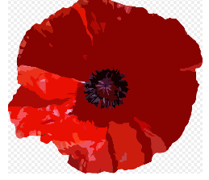  Using a range of brushes to create different effects  To explain features of art from historical periods (WW2)  DT  In Design and Technology we are:  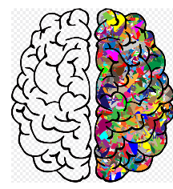  Designing a product that meets a given criteria  Using research to create a product for a given market  Ensuring a product is attractive and presentable  Explaining my design and how they meet the criteria set  Follow a step by step plan choosing appropriate materials and tools fit for purpose  Food Technology:  In Food Technology we are:  Preparing and cooking a variety of savoury dishes  Using a range of cooking techniques  Understanding and applying the principles of a balanced and varied diet  Following basic hygiene routine and practices  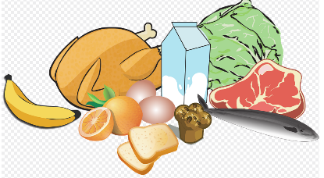  Following step by step instructions |  | PE  In PE young people will be focusing on Athletics including:  Different types of running including relay races, sprinting and long distance.  Practicing running at different speeds including fast, medium and slow speeds  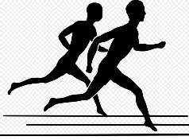  Throwing with accuracy and control  Comparing performances with previous ones and demonstrating improvement  Obstacle courses including running, jumping and throwing  Music:  In Music pupils will:  Begin to create their own composition using Chrome Music Lab or garage band  Learn about the fundamentals of composition (drum beats, melody and chords)  Improvise their rhythms within their drum beats, melodies and chords.  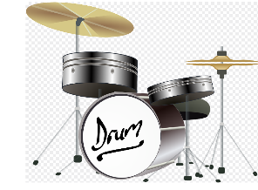  Create a short melody using notes C D E A |  | MFL  In Spanish we are:  Learning the names for 7 different types of sea creatures  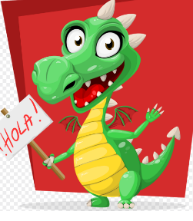  Exploring patterns through sounds and songs  Use correct pronunciation when practicing speaking  Practicing listening skills  Starting to write key words learnt  RE  In RE we are focusing on:  Harvest festival- the traditions that surround this, how and why it is celebrated  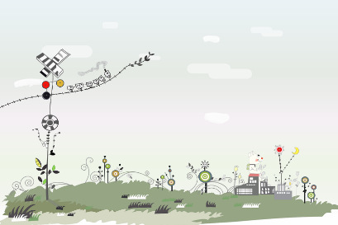  Christianity- looking specifically looking at worship, traditions, rules and rituals

