Pearl Base  Overview of Learning. | This term we are learning about  “Can all change be good?” |  | Our Change Maker principle,  this term is 'Future’ | 

English | Maths | Science |  | Computing |  | PSHE/RSE
Pupils will be encouraged to foster a love of reading through engaging, interactive, and enjoyable activities, promoting critical thinking and a deeper appreciation of literature.   | Pupils will begin this half term by studying ratio.  They will be introduced to and be able to use ratio language and the ratio symbol.  Pupils will look at the additive and multiplicative relationship between numbers as well as ratio and fractions.  They will become familiar with scale drawing and learn how to use scale factors.  They will also be taught how ratio is used in recipes, and embed this knowledge in their food technology lessons.  Pupils will also consolidate their learning by solving a variety of ratio and proportion problems.   | This half term pupils are learning about acids and alkalis and chemical reactions.  There is a focus on practical chemistry skills and laboratory safety.  Pupils will use indicators to classify acids and alkalis, applying their knowledge to explain how to behave safely when using acids, using hazard symbols to inform their decisions.   |  | Pupils will learn the basics of coding through using the BBC Microbit computers.  By using these devices, pupils will learn the programming fundamentals of managing inputs and outputs, declaring variables, loops and conditional statements.  Through constructing their programs, they will learn resilience and problem-solving skills as they debug and correct their code.  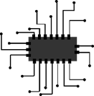 |  | This half term, pupils will focus on building resilience and self-confidence and working as a team to solve simple life problems.  They will move on to growing their communication skills and especially, focussing on other people’s body language. This will support their ability to communicate with their peers and adults around them. This half term will finish with the important topic of ‘money matters’.  
Geography & History | Art and DT |  | PE & Music |  | MFL & RE
History  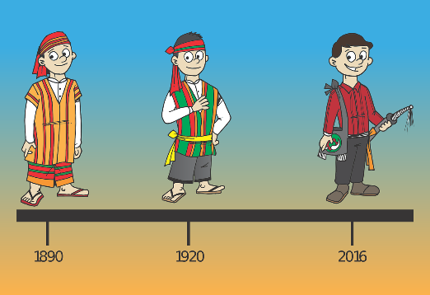  Pupils will be starting with developing their key historical skills. This will include: understanding the passage of time in decades and centuries, however we identify the century we are in and what is meant by chronology. We will then look at the evidence used by historians – both primary and secondary and what these are, as well as starting to make inferences based on historical sources. From there we will start our main topic on The Norman Invasion of 1066, looking at how England was run in 1066 and who the main contenders for the throne were following the death of Edward the Confessor.  Geography  This half term pupils will be focused on the continent of Europe, using the back drop of the European football tournament being held in Germany.  Pupils will have the opportunity to explore and research several major countries in Europe before being given the freedom to complete their own mini project on a European country of their choice.  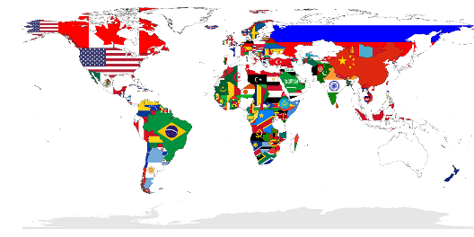 | Art  Pupils will learn about water colour, creating their very own water colour landscapes and sunsets.  Pupils will be able to explain why they have chosen specific techniques to create their art and they will be able to explain how and why they have used different tools to create their art.  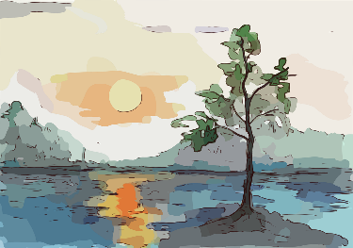  DT  Pupils will explore the design and functionality of wind turbines.  They will research different designs of wind turbines and then design their own. Pupils will consider culture and society in their plans and designs. They will consider factors such as the number and shape of the blades, the height of the tower, and the materials used.  Pupils will evaluate their products against clear criteria and show that they can test and evaluate their products.    Food Technology  Pupils will begin to understand where food and ingredients come from and the main seasons in which they can be found.  They will continue to cook predominantly savoury dishes whilst practicing their cutting skills and using different ways of cooking.  We will take a further look into the nutrition and health benefits of the ingredients used so that students can check they are eating a varied diet.  When they have finished preparing their food, students will be able to wash up and put away their utensils independently.  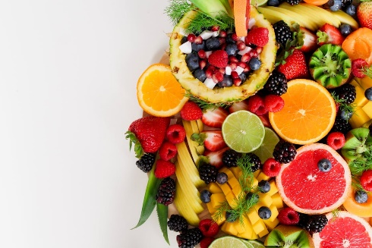 |  | PE  Pupils will explore a variety of new pieces of equipment that relate to the Athletics topic.  They will learn how to use it safely while performing with control, accuracy and care.  Pupils will learn, copy, repeat and combine transferable athletics actions and skills such as throwing, jumping and running at different speeds including relays.  They will be encouraged to use key words to describe their actions. Pupils will begin to give feedback on performances and compare their performances with previous ones to demonstrate improvement.  Pupils will be encouraged to work independently and with others. They will expand their knowledge and vocabulary that is PE and Athletics specific.    Music  Pupils will produce a remix composition based on a popular song. They will explore how to create and manipulate sounds as well as adding typical remix techniques relating to music technology (pan, reverb, delay etc).  Pupils will also use loops on GarageBand to make their composition unique and personal to their own tastes. They will be exploring how musical dimensions (dynamics, tempo, timbre, texture, pitch, melody) can affect a composition and how these elements can be manipulated to produce a successful remix composition.   |  | MFL  Pupils will follow the unit sequence set out on Language Angels.  In this unit, pupils will learn 10 common shapes and the numbers 1-5 in Spanish.  By the end of the unit, pupils will be able to recognise, recall, remember and spell up to ten shape nouns with their indefinite article.    RE  Pupils will study Christianity and how Harvest is celebrated.  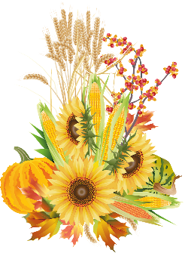  This learning will be complimented by visits from our local vicar.

