Opal Base  Overview of Learning | This term we are learning about  “Can all change be good?” |  | Our Change Maker principle,  this term is 'Future’ | 

English | Maths | Science |  | Computing |  | PSHE/RSE
This half term we are having a HUGE focus on reading for pleasure within our English lessons.  We are:  - Visiting our school library on a regular basis  - Daily reading, encouraging children to read how they are most comfortable  - Choosing a reading book to take home  - Reading a class book during our English lessons and completing work linked to this.  - Putting ourselves in the characters shoes, how would they feel?  - Focus attention on the setting in the story.  - Read in pairs, supporting the idea of reading for pleasure as well as supporting peers and their love for reading.  - Thinking of ideas of how to make reading more fun – popcorn while you read, beanbags and blankets. | Focus on place value.  - Count objects to 100 by making 10s  - Recognising tens and ones  - Using place value charts  - Partitioning of numbers up to 1,000  - Represent numbers from 10 up to 1,000  - Number line 1,000  - Thousands  - Find 1, 10, 100, 1000 more or less.  - Numbers to 10,000 and 100,000.  - Read and write numbers  - Compare and order integer  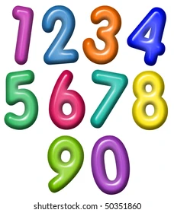  - Powers of 10 | Students will be able to:  - Identify reversible changes (revisit changes of state)  - Describe dissolving (revisit from dissolving and separating mixtures).  - Safely investigate how the temperature of water affects the amount of sugar that will dissolve  - Identify and explain irreversible chemical changes.  - Recognise the difference between a chemical reaction and a physical change and explain using evidence from simple experiments |  | Students will be able to:  - Basic programming concepts  - Investigate the triggers and events like making the lights flash & playing sounds  - Explore the different input sensors – button A, B or both together, tilt, accelerometer, light  - Use the teaching resources on the BBC Microbit website   |  | Growing and Changing  - Personal strengths and achievements; managing and re-framing setback  - Physical and emotional changes in puberty; personal hygiene routines; support with puberty  - Personal identity; recognising individuality and different qualities; mental wellbeing.  Keeping Safe  - Safety in the local environment and unfamiliar places  - Medicines and household products; drugs common to everyday life  - Keeping safe in different situations.  - Keeping personal information safe;
Geography & History | Art and DT |  | PE & Music |  | MFL
History:  To focus on WW2, finding out who was involved, what countries were invaded and how the war ended.  - To look at the outbreak of the war  - To study the evacuation further.  - To understand what life was like in WW2 and focus on rationing  - To study the role of women in WW2  - To study the holocaust further  - To understand key events of WW2    Geography:  I can locate European countries including Russia, concentrating on their environmental regions, key physical and human characteristics countries | Art  In Art we are focusing on drawing and painting specifically:  Producing art in the style of another artist  Mixing paint to create primary and secondary colours  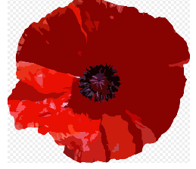  Using a range of brushes to create different effects  To explain features of art from historical periods (WW2)  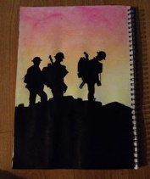  DT  To make a wind turbine.  Children will explore the design and functionality of wind turbines.  To make bomb shelters to link to WW2 for our History focus.  Food Technology:  To understand food hygiene and the importance of being safe when cooking.  Focus on:  Chopping  Slicing  Cracking eggs  Mixing  We will be making:  Butterfly buns, Crustless quiche, Victoria Sponge, sausage rolls, Summer Trifle, eton mess and spaghetti and meatballs. |  | PE  - To compare performances with previous ones, demonstrating improvement  - About stamina  - Set up an obstacle course that involves running, jumping, throwing.  - Jump high and stick a post it on the wall or mark it with chalk.  - Difference between track and field events.  - Zone ball.  - Fancy dress relays.  Music:  - Students will begin to create their own composition using Chrome Music Lab or GarageBand. They will learn about the fundamentals of a composition (drum beat, melody and chords).  - Some students may begin to improvise their own rhythms within their drum beats, melodies or chords.  - Students will improvise a short melody using the notes C D E G A.  - Some students may use the musical elements and a wide range of music to make their composition more exciting.   |  | MFL  Lesson 1 I n this lesson pupils will learn how to recognise, recall and spell five different shapes with their indefinite article/determiner in the foreign language.  Lesson 2 In this lesson pupils will learn how to recognise, recall and spell a further five different shapes with their indefinite article/determiner in the foreign language.  Lesson 3 In this lesson pupils will consolidate all ten shapes in the foreign language with a particular focus on the article/ determiner.  Lesson 4 In this lesson pupils will further consolidate all ten shapes from the unit whilst revising and consolidating numbers 1-5 in the foreign language.  Lesson 5 In this lesson pupils will consolidate numbers and shapes in the foreign language.  Lesson 6 In this lesson pupils will revise and consolidate all language covered in the unit and complete the end of unit assessment.  RE  Harvest, Christianity, Visits from Tom Brown (Vicar)

