Jade Base  Overview of Learning | This term we are learning about  “Can all change be good?” |  | Our Change Maker principle,  this term is 'Future’ | 

English | Maths | Science |  | Computing |  | PSHE/RSE
This half term we will be aiming to foster a love of reading among young people through engaging, interactive, and enjoyable reading activities.  We will be supporting children to explore and discuss a variety of picture books including;  - The Very Hungry Caterpillar by Eric Carle  - Monkey Puzzle by Julia Donaldson  - The Teeny Weeny Tadpole by Sheridan Cain  - The Perfect Ribbit  - Owl Babies by Martin Waddell  We will be working on reading skills and basic comprehension skills.  Children will also be sharing and discussing their favourite stories, authors and characters.  Linked to each book, we will be completing a range of writing activities.  We will be learning to:  - Write sentences by saying out loud what we are going to write about,  - Compose a sentence orally before writing it ·  - Re-read what we have written to check that it makes sense.  - Leave spaces between words.  - Join words and joining clauses using and.  - Begin to punctuate sentences using a capital letter and a full stop, question · mark or exclamation mark. | Students will be:  Learning about multiplication and division.  Be able to count in multiples of 2s, 5s and 10s.  Making arrays.  Recognising equal groups.  Making doubles.  Learning about fractions.  Recognising and finding a half.  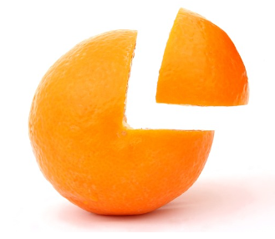  Recognising and finding a quarter. | This Half Term we will be learning about working scientifically including observing over time; pattern seeking; identifying, classifying and grouping; comparative and fair testing (controlled investigations).  Students will:  Explore simple chemical reactions and describe what they, see, hear, smell and feel.  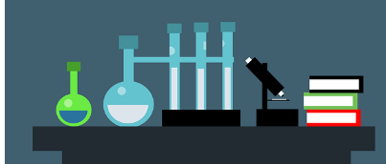  Talk about the differences between materials and changes they notice eg. dissolving, melting, freezing, fizzing, changing colour. |  | Students will be:  Continuing to practise independently switching on a laptop and logging in using their username and password.  Developing basic typing skills using Microsoft Word and games including, BBC Dancemat and Typing Club.  Continuing to develop their understanding of e-safety.   |  | Children will be learning about:  Growing and Changing  - Recognising what makes them unique and special; feelings; managing when things go wrong  - Growing older; naming body parts; moving class or year  Keeping Safe  - How rules and age restrictions help us; keeping safe online  - Safety in different environments; risk and safety at home; emergencies
Geography & History | Art and DT |  | PE & Music |  | MFL
History:  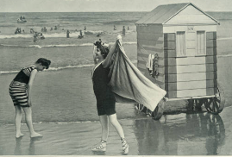  We will be learning about seaside holidays now and then, with a focus on how seaside holidays have changed through the ages.  We will learn about:  - Changes in transport to holiday destinations.  - How holiday clothing has changed since Victorian times  - Bathing machines  - Popular seaside activities through the ages.  Geography:  Students will:  Learn about human and physical features- physical features and vocab in reference to towns, shops, roads, rail and bus station.  Be able to name and describe a seaside town.  Be able to name some of the main towns and cities in the United Kingdom and use the terms city, town, village, factory, farm, house, office, port, harbour and shop.  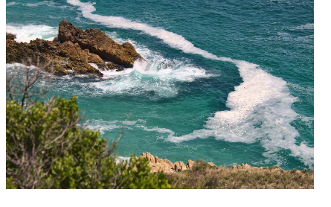 | Art  This Half Term our focus will be linked to geography and the coast.  Students will:  Create moods in art work.  Produce a piece of art in response to the work of another artist.  Use and name the primary and secondary colours.  Mix paint to create all the secondary colours.  DT  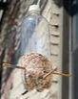  Students will be designing and making bird feeders.  We will discuss the importance of providing habitats for wildlife, including birds.  Students will design a bird feeder using materials such as empty plastic bottles, twine, and wooden sticks.  They will learn how to safely cut holes in the plastic bottle to create feeding ports.  Students will be encouraged to construct their bird feeders, ensuring they are sturdy and attractive to birds.  We will hang the bird feeders in appropriate outdoor spaces and observe any bird activity.  Food Technology:  Students will:  Continue to discuss what a healthy diet is.  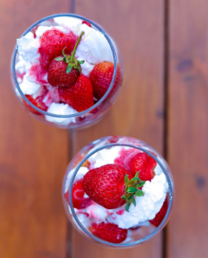  Be able to cut, spread and slice food safely to make a healthy dish. Follow recipes to make crustless quiches, sausage rolls, cheese straws, Eton mess, frozen yoghurt dessert and a chocolate dessert. |  | PE  This Half Term our focus will be athletics.  Students will learn:  To use equipment safely.  To move with control and care.  To copy and repeat actions and skills.  To move safely in a space.  To throw in different ways.  To move and stop safely.  To throw underarm.  To talk about something, I did different to someone else.  To copy and remember actions.  To work independently and with others.  Music:  Students will explore how to compose their own short jingle exploring notes on a steel tongue drum. They will develop their ability to identify lower and higher pitches.  Students will also explore the definition of a melody and how to create a melody using three notes (C G A). |  | RE  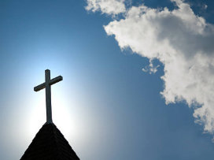  This Half Term in RE we will be learning about Christianity.  MFL  Bajo el mar Under the sea  In this unit pupils will learn 7 sea creatures (nouns and definite articles) in Spanish.  

