Ruby Base | This term we are learning about  “What makes us?’ | 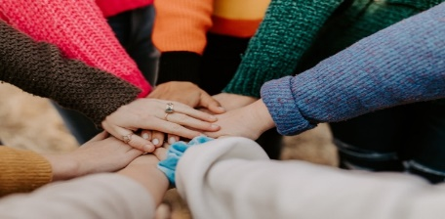 | Our Change Maker principle, this term is ‘adaptability’ | 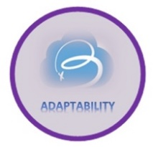

English | Maths |  | Science |  | Computing | PSHE/RSE
Text- Pugs of the Frozen North  Identify features of information text.  Discuss characters, plot and settings.  Define and identify features of explanation texts and discuss the purpose.  Extracting information from the text.  Write a recount based on the narrative.  Answering retrieval questions and predicting what might happen next.  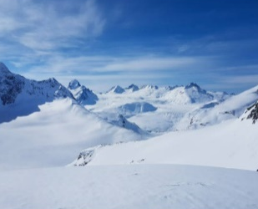  To be able to draft write by composing a sentence orally before writing it.  Extending sentences by using more than one clause and using a range of conjunctions such as when, if, because and although  Develop our understanding of vocabulary and unfamiliar words. | Length and Height-  Measure with accuracy in mm, cm, and m  Find equivalent lengths and convert mm, cm and m  Compare lengths  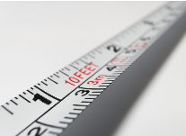  Adding and subtracting lengths  Mass and Capacity-  Using pictorial representations with accuracy  Measure mass in grams and kilograms  Finding equivalent masses  Comparing, adding and subtracting mass |  | In science the focus will be on Animals including Humans investigating:  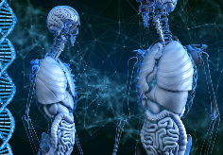  Tooth decay and the impacts of sugar can have on health  The types and purpose of human and animal teeth  The digestive system and the purpose of each part in the digestive system  Focusing on the food chain investigating pray, predators and perpetrators, |  | Learning the basics of coding through the use of microbits and focusing on:  Inputs, outputs and the correlation between them  Different types of inputs  Creating simple programs that respond to user input  Debugging  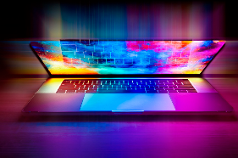  Building algorithms | In PSHE:  The focus is on Physical health and Mental wellbeing  What affects mental health and ways to take care of it  Managing change, loss and bereavement.  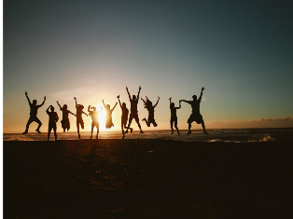  They will also look at managing time online
Geography & History |  | Art and DT |  | PE & Music |  |  | MFL & RE
In Geography we are:  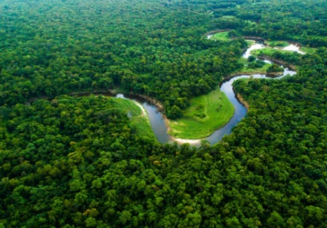  Focusing on Rainforests investigating:  Locating rainforests using maps and atlases  Understanding the differing rainforest climates  Layers of the rainforests  Comparison of forests in the UK to amazon rainforests  Ways in which Humans affect the rainforest and ways which we can help protect them  In History we are learning about WW1:  Knowing how WW1 started and the alliance system  Investigating soldiers recruited and the methods in this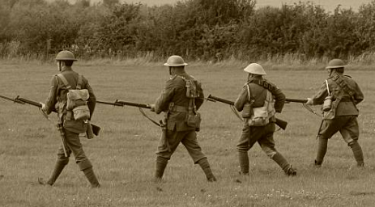  Looking at life in trenches and the impact this had  Evaluating the different types of weapons used in WW and comparing it to weapons used today  Researching Women’s role in the WW1 and the effects |  | In Art we are learning to:  Create 3D pieces of Art by:  Making a clay sculpture  Cutting, rolling and shaping a range of materials  Sculpting malleable materials  In Design and Technology, we are:  Investigating and analysing a range of products  Designing a product that looks attractive and presentable  Prove my ideas meet a set criterion  Follow a step by step plan choosing correct and appropriate materials and tools  Using a research proposal and design to create a finished product  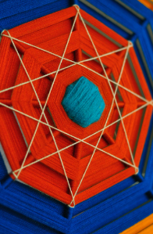 |  | In PE:  Young people will learn how to use equipment safely.  They will have the opportunity to explore skills such as throwing, catching and hitting a ball with a bat.  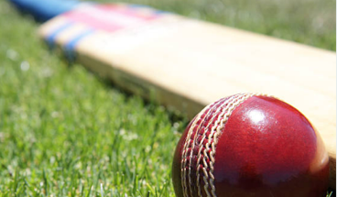  Young people will be encouraged to copy actions, work independently and with a partner as well as learning rules of games.  They will compare something they have done to what others have done and talk about how it is the same or different. Tactics of games will be introduced as well as exploring the best space to be in.  Music-  Students will improvise on a variety of instruments based on a given chord sequence consisting of two simple chords. They will be exploring how to improvise a melody, a chord sequence itself as well as a drum beat.  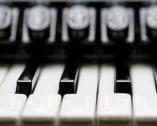  Students will be working together in a small ensemble to understand the importance of ensemble skills itself, as well as performing in time and developing their confidence.  Students may choose which element they will improvise (a chord sequence, a melody or a drum beat) when they create their performances. |  |  | In Spanish we are learning about Seasons:  Students will be able to recall up to 4 different seasons in Spanish  Students will start to use the correct pronunciation when speaking  The young people will be able to start say their favourite season in a sentence in Spanish  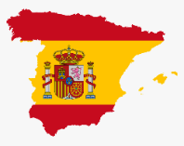  RE  Buddhism-  Understanding the main Buddhist beliefs  Exploring symbols and practices  Learning about Sanga

