Pearl Base | This term we are learning about  “What makes us?” | 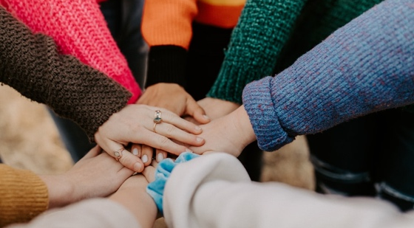 | Our Change Maker principle, this term is 'Adaptability’ | 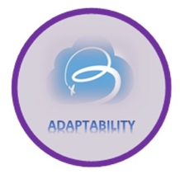

English | Maths | Science |  | Computing |  | PSHE/RSE
This half term students will be  focussing on Travel Writing.  We will take an in-depth look at vocabulary, fact and opinion, rhetorical questioning, how to use our knowledge of grammar to write  emotive sentences and other  language devices. This process will  include taking notes and developing  initial ideas, drawing on reading and  research. Students will evaluate and edit by: assessing the effectiveness of their own and others’ writing. To propose changes to vocabulary, grammar and punctuation to enhance effects and clarify meaning. This will culminate in young people creating a persuasive piece of work, writing in the style of a Travel Writer.  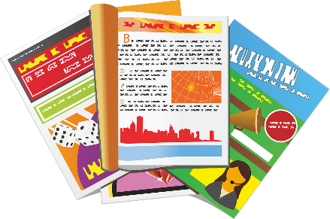 | Most students will continue to study equivalent, improper and mixed fractions, ordering, adding and subtracting them.  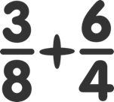  They will then move on to looking at decimals and percentages.  Some students will study place value and proportion, looking at fraction, decimal & percentage equivalence.   | Students will be exploring DNA structure and genes and how this carries our genetic information. We will look at genetic variation within a species and use Punnett Squares to determine the probability of characteristics being expressed in a person.  We will be looking at genetic disorders.  We will be classifying traits as being inherited or environmental and diving into the difference between continuous and discontinuous variation, representing variation data using the correct type of graph. Pupils will learn how variation results in competition for resources and how this can lead to natural selection and how this drives evolution. |  | Students will learn some spreadsheet and data handling basics.  Through using Microsoft Excel they will learn about data entry & formatting, using basic mathematical operators & formulae as well as presenting data in graphs & charts.  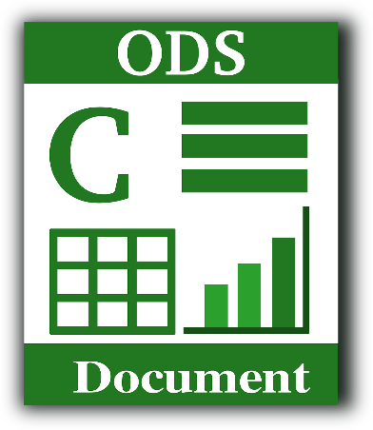 |  | Students will be focusing on building relationships and looking at how self-worth, romance and friendships (including online) and relationship boundaries affect relationships.  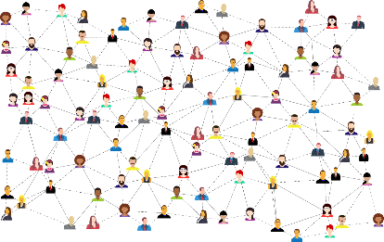
History & Geography | Art and DT |  | PE & Music |  | MFL
History:  Students will focus on the religious reformation in Europe and the growing popularity of Protestantism, highlighting the fundamental differences between Catholicism and Protestantism, Henry VIII and the split from the Catholic Church, Edward and the growth of Protestantism in England, Mary I and the religious persecutions and Elizabeth I and the religious settlement.  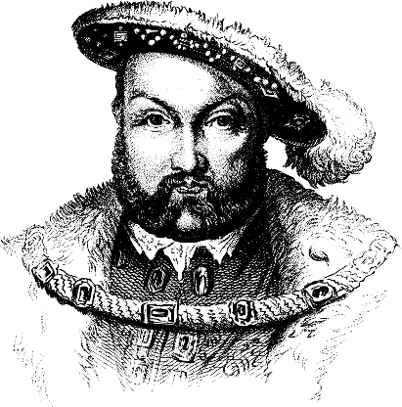  Geography:  Students will explore World Development and look at the differences between developed and developing countries.  They will study the indicators for development such as Gross Domestic Product (GDP), literacy rates, health care and Human Development Index (HDE).  They will highlight the problems of uneven development and how sustainable aid and fair trade can be used to support development especially improve child poverty rates.   | Art:  Students will learn about the history of art, craft, design and architecture, including periods, styles and major movements from ancient times right up to the present.  The type of art that we will be studying is called ‘Adinkra.’ Students will make an imaginative and creative print influenced by Adinkra symbols.    DT:  Students will use research and exploration, such as the study of different cultures to understand user needs.  They will develop and communicate design ideas using annotated sketches, detailed plans, 3D mathematical modelling, oral and digital presentations and computer-based tools.  Students will develop specifications to inform the design of innovative, functional, appealing products that respond to the needs of a variety of situations.  We will be designing and making a personalised phone case.  Food Technology:  Pupils will continue to apply their cutting skills when preparing and cooking predominantly savoury dishes. These include including choosing and adapting a recipe of their choosing.  Pupils will be able to identify the correct method of cooking for all recipes. They will be able to effectively learn and use frying, baking, grilling, toasting and boiling methods.  As part of their food technology lessons students will be able to gather the correct ingredients from around the kitchen according to the recipe then follow the recipe accurately.  When they have finished preparing their food students will wash up and put away their utensils independently.  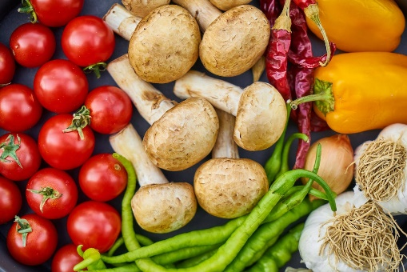 |  | PE:  Young people will learn how to use equipment safely. They will have the opportunity to explore skills such as throwing, catching and games that require hitting a ball with a bat. Young people will be encouraged to copy actions, work independently and with a partner as well as learning rules of games. They will compare their performance with previous ones to demonstrate improvements. Tactics of games will be introduced as well as exploring the best space to be in to support team-mates. Striking and fielding games will be played whereby young people have the opportunity to take on different roles within a team for example; batter, fielder, bowler etc.    Music:  Students will be exploring reggae music and performing 'Three Little Birds' as an ensemble or small ensemble group. They will be developing key ensemble skills such as performing in time and some may even take a leading role within their ensemble. Students will be accessing a wide range of instruments (keyboard, ukulele or guitar) and will have the choice to choose an instrument to focus their performance on.  Their musical vocabulary will be developed further, ensuring that they are confident when describing key elements such as pitch, tempo, timbre, instrumentation, dynamics and texture. Students will also be exploring the term 'improvisation' and be able to experiment further on their chosen instrument using three or four notes.   |  | MFL:  Pupils will practice basic  phonic knowledge for  pronunciation and spelling of  Spanish words.  They will work on improving  memory skills through a  variety of interactive  activities.    RE:  Students will understand the basic principles of Buddhism, including the Four Noble Truths and the Eightfold Path. They will learn about the life of Siddhartha Gautama and his journey towards enlightenment.  Students will learn about the role of meditation, rituals, and the Sangha in Buddhist life. They will understand Wesak’s significance, how and why it is celebrated among Buddhists.  

